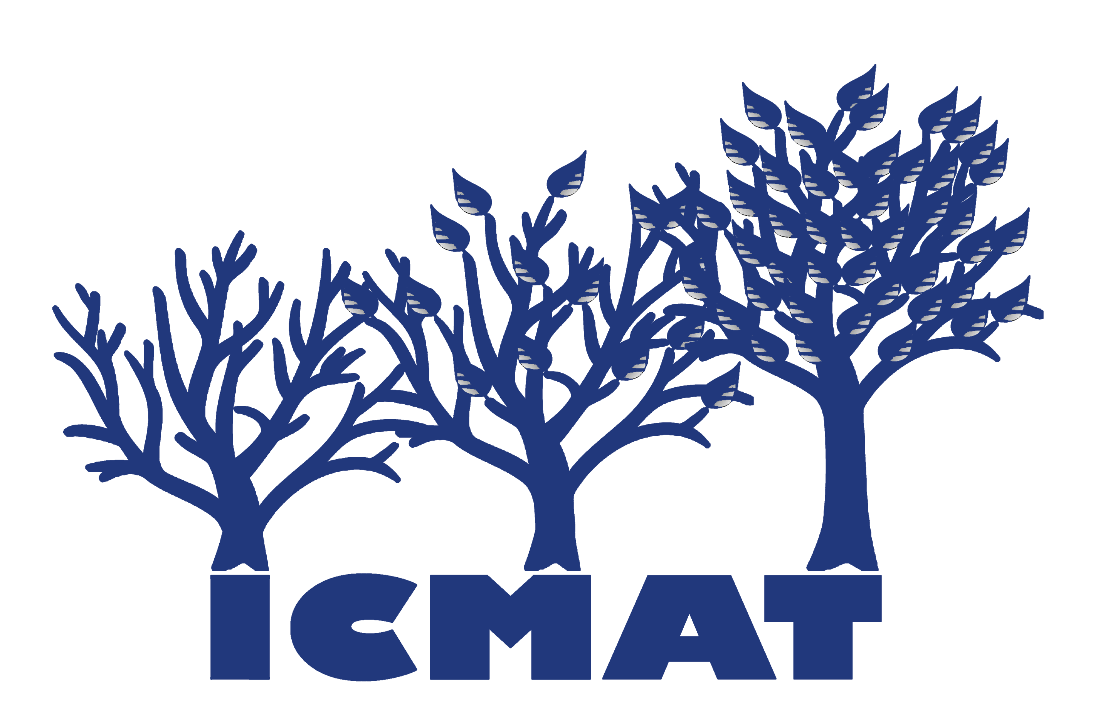 PRIVACY NOTICE – Pupil Information

This notice is to help you understand how and why we collect pupil’s personal information and what we do with that information. It also explains the decisions that you can make about your own information.
What is "personal information"?
Personal information is information that the School holds about you and which identifies you. This includes information such as your name, date of birth and address as well as things like exam results, medical details and behaviour records. The School may also record your religion or ethnic group. CCTV, photos and video recordings of you are also personal information.
Why do we collect and use pupil information?
We collect and use pupil information undersection 537A of the Education Act 1996 and section 83 of the Children Act 1989. We also comply with Article 6(1)(c) & (e) and Article 9(2)(b) of the General Data Protection Regulation (GDPR).
We use the pupil data:

- to support pupil learning
- to monitor and report on pupil progress
- to provide appropriate pastoral care, including safeguarding
- to assess the quality of our services
- to comply with the law regarding data sharing
- to support pupils to decide what to do after they leave school

The categories of pupil information that we collect, hold and share include:

- Personal information (such as name, unique pupil number, relevant medical and special education needs information and address)
- Characteristics (such as ethnicity, language, nationality, country of birth and free school meal eligibility)
- Attendance information (such as sessions attended, number of absences and absence reasons)
- Special educational needs information
- Relevant medical information
- Exclusions and behavioural information
- Assessment information (Pupil progress data, exam results)
- Post 16 learning information

Collecting pupil information
Whilst the majority of pupil information you provide to us is mandatory, some of it is provided to us on a voluntary basis. In order to comply with the General Data Protection Regulation, we will inform you whether you are required to provide certain pupil information to us or if you have a choice in this.

Storing pupil data
We keep information on pupils on computer systems and also on paper.

We hold education records securely and retain them from the pupil’s date of birth until they reach the age of 25 (or longer if the pupil has an EHCP), after which time they are safely destroyed.

In exceptional circumstances we may keep your information for a longer time than usual, but we would only do so if we had a good reason and only if we are allowed to do so under data protection law.
We can keep information about you for a very long time or even indefinitely if we need this for historical, research or statistical purposes.

There are strict controls on who can see pupil information. We will not share any data if you advise us that you do not want it shared unless it is the only way we can make sure you stay safe or we are legally required to do so.

Who do we share pupil information with?
We routinely share pupil information with:

- Schools or colleges that pupils attend after leaving us
- Our local authority (Medway Council) and their commissioned providers of local authority services.
- The Department for Education (DfE)
- Examination awarding bodies
- Carers advisors
- NHS

Aged 14+ qualifications
For pupils enrolling for post 14 qualifications, the Learning Records Service will give us a pupil’s unique learner number (ULN) and may also give us details about the pupil’s learning or qualifications.

Why we share pupil information
We do not share information about our pupils with anyone without consent unless the law and our policies allow us to do so.

We share pupils’ data with the Department for Education (DfE) on a statutory basis. This data sharing underpins school funding and educational attainment policy and monitoring.

We are required to share information about our pupils with the (DfE) under regulation 5 of The Education (Information About Individual Pupils) (England) Regulations 2013.

Data collection requirements
To find out more about the data collection requirements placed on us by the Department for Education (for example; via the school census) go to https://www.gov.uk/education/data-collection-and-censuses-for-schools.

Youth support services
What is different about pupils aged 13+?
Once our pupils reach the age of 13, we also pass pupil information to our local authority and / or provider of youth support services as they have responsibilities in relation to the education or training of 13-19 year olds under section 507B of the Education Act 1996.

This enables them to provide services as follows:

- youth support services
- careers advisers

A parent / guardian can request that only their child’s name, address and date of birth is passed to their local authority or provider of youth support services by informing us. This right is transferred to the child / pupil once he/she reaches the age 16.

Our pupils aged 16+
We will also share certain information about pupils aged 16+ with our local authority and / or provider of youth support services as they have responsibilities in relation to the education or training of 13-19 year olds under section 507B of the Education Act 1996.

This enables them to provide services as follows:

- post-16 education and training providers
- youth support services
- careers advisers

For more information about services for young people, please visit our local authority website.

The National Pupil Database (NPD)
The NPD is owned and managed by the Department for Education and contains information about pupils in schools in England. It provides invaluable evidence on educational performance to inform independent research, as well as studies commissioned by the Department. It is held in electronic format for statistical purposes. This information is securely collected from a range of sources including schools, local authorities and awarding bodies.

We are required by law, to provide information about our pupils to the DfE as part of statutory data collections such as the school census and early years’ census. Some of this information is then stored in the NPD. The law that allows this is the Education (Information About Individual Pupils) (England) Regulations 2013.

To find out more about the pupil information we share with the department, for the purpose of data collections, go to https://www.gov.uk/education/data-collection-and-censuses-for-schools.

To find out more about the NPD, go to https://www.gov.uk/government/publications/national-pupil-database-user-guide-and-supporting-information.

The department may share information about our pupils from the NPD with third parties who promote the education or well-being of children in England by:

- conducting research or analysis
- producing statistics
- providing information, advice or guidance

The Department has robust processes in place to ensure the confidentiality of our data is maintained and there are stringent controls in place regarding access and use of the data. Decisions on whether DfE releases data to third parties are subject to a strict approval process and based on a detailed assessment of:

- who is requesting the data
- the purpose for which it is required
- the level and sensitivity of data requested: and
- the arrangements in place to store and handle the data

To be granted access to pupil information, organisations must comply with strict terms and conditions covering the confidentiality and handling of the data, security arrangements and retention and use of the data.

For more information about the department’s data sharing process, please visit:
https://www.gov.uk/data-protection-how-we-collect-and-share-research-data

For information about which organisations the department has provided pupil information, (and for which project), please visit the following website: https://www.gov.uk/government/publications/national-pupil-database-requests-received

To contact DfE: https://www.gov.uk/contact-dfe

Requesting access to your personal data
Under data protection legislation, parents and pupils have the right to request access to information about them that we hold. To make a request for your personal information, or be given access to your child’s educational record, contact dpo@unify-i.co.uk (our data protection services).

You also have the right to:
- object to processing of personal data that is likely to cause, or is causing, damage or distress
- prevent processing for the purpose of direct marketing
- object to decisions being taken by automated means
- in certain circumstances, have inaccurate personal data rectified, blocked, erased or destroyed; and
- claim compensation for damages caused by a breach of the Data Protection regulations

If you have a concern about the way we are collecting or using your personal data, you should raise your concern with us in the first instance or directly to the Information Commissioner’s Office at https://ico.org.uk/concerns/

Contact:
If you would like to discuss anything in this privacy notice, please contact Mrs C Delahay at The Rowans AP Academy – office@therowansap.co.uk.

