14th April 2020
Dear parents/carers

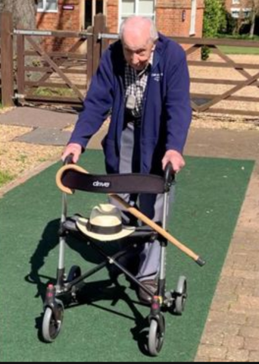
First and foremost, thank you for your ongoing support, I know that this can be a challenging time but equally it can be a time for households to reconnect, to spend quality time together and to support each other. We are reminded daily of the terrible impacts of Covid-19 but I am certain that there are equally many positive stories of people connecting and supporting each other, such as that of army veteran, Tom Moore who, at the age of 99, has raised £2 million for the NHS by walking laps around his garden.
https://www.bbc.co.uk/news/uk-england-beds-bucks-herts-52278746

We may not be able to raise millions of pounds but each one of us, in our own way, can support NHS workers by staying at home and by following government guidance. We can also support each other by continuing to develop and practice our core values of kindness, commitment and resilience. I also hope you have been enjoying some of the warmer weather, either in your garden or as part of your daily exercise.

We are all missing being at school and look forward to when we can return, although we must wait for government guidance on this. I would like to offer you some ideas to help you continue your child’s education as much as possible during school closure and to support you and your family by keeping in touch.

All pupils have an allocated member of staff who will be in regular contact, offering support and welfare checks. In addition to this, from Monday 20th April, you may also be contacted by teachers who will offer specific support and guidance with learning tasks. It is important that pupils continue to access learning via google classroom, where there is a menu of learning opportunities for pupils to choose from. We do expect pupils to access some learning each week day, as part of the balance between education, entertainment, exercise, rest and relaxation.

Here is a reminder of contact numbers for key staff at school:
Mrs May | 07710143036 | Mrs Jones | 07710143029
Miss Johnson | 07710143033 | Miss Webb | 07710143027
Mrs Martin | 07734975338

Finally, I hope you stay safe and well during the upcoming weeks. We love hearing your news so please share with us and encourage your children to do the same via our Facebook page (The Rowans AP Academy) and Twitter feed (@TheRowansAP). Please be assured that school staff remain available for support and guidance. Now is the time to work together, support each other and model kindness within our families and our local communities.

Be safe and take care of one another.

Mrs May
Headteacher

