6th September 2021

Dear parents/carers

Welcome back to the start of the school year. It has been lovely to see pupils back in school eager to learn, engage in lessons and make progress.

We were once again, delighted with the outcomes of our year 11 pupils who all achieved well and have the GCSEs and BTEC qualifications they need for their next steps in education or employment. Many pupils in Year 10 also achieved qualifications and this has prepared and motivated them for Year 11.

COVID update
In line with updated Government guidance I am writing to update you about the arrangements in school in relation to COVID.

The Government no longer recommends that pupils stay in consistent groups (‘bubbles’). There will no longer be a staggered break or lunchtime so all pupils will return to break at 10.45-11.00 and lunch at 1.00-1.25. Assemblies for the whole school will also return each Friday.

Social distancing is no longer a requirement. However, we will continue to encourage pupils to wash their hands regularly and use the hand sanitiser provided. Windows and doors will be opened to increase ventilation. Face coverings MUST be worn on the school vehicles but are not needed around school. We will continue with our enhanced cleaning programme.

In addition to pupils doing two tests at the start of the term, we will continue to test pupils twice a week in school. Where pupils have opted to test at home, testing kits will be regularly sent home.

Pupils should wear full school uniform and bring their PE kit into school to change for PE lessons. We have both school and PE uniform in school which can be purchased for £7.00 per item via the school gateway.

Isolation
Where a pupil has symptoms of Covid or has tested positive they are required to self isolate at home as previously. Parents / Carers must immediately inform the School on 01634 338803.

Individuals are not required to self-isolate if they live in the same household as someone with COVID-19, or are a close contact of someone with COVID-19, and any of the following apply:
- they are fully vaccinated
- they are below the age of 18 years and 6 months
- they have taken part in or are currently part of an approved COVID-19 vaccine trial
- they are not able to get vaccinated for medical reasons

Instead, they will be contacted by NHS Test and Trace, informed they have been in close contact with a positive case and advised to take a PCR test. The Government encourages all individuals to take a PCR test if advised to do so.
Attendance
Government Guidance states that all pupils should attend school. There is a clear link between school attendance and pupil progress. It is your responsibility to contact the school if your child is absent from school, please do not wait for the school to call you.

Pupils who are absent due to COVID related reasons will be provided with learning remotely, via google classroom. This will be monitored by teachers and feedback given.

Thank you once again for your continued support. I look forward to seeing you all in person again throughout the school year.

Kind regards

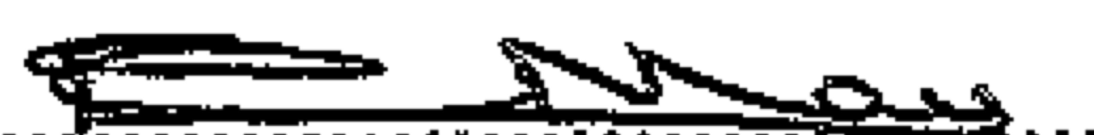

Mrs F May

