Provider Access Policy Statement

Implemented and reviewed | K Martin
Date of implementation | September 2018
Date of review | September 2025
Next review date | September 2026

Name of School: The Rowans AP Academy
Part of The Howard Multi Academy Trust
To include The Department of Education, July 2021: “Baker Clause” and the Provider Access Legislation, January 2023.
Ownership: The Rowans AP Academy
Date updated: July 2025
Rationale
High quality careers education and guidance in school or college is critical to young people’s futures. It helps to prepare them for the workplace by providing a clear understanding of the world of work including the routes to jobs and careers that they might find engaging and rewarding. It supports them to acquire the self-development and career management skills they need to achieve positive employment destinations. This helps students to choose their pathways, improve their life opportunities and contribute to a productive and successful economy.
As the number of apprenticeships rises every year, it becomes increasingly important that all young people have a full understanding of all the options available to them post-16 and post-18 including wider technical education options such as T-Levels and Higher Technical Qualifications.
Commitment
The Rowans AP Academy is committed to ensuring there is an opportunity for a range of education and training providers to access students, for the purpose of informing them about approved technical education qualifications and apprenticeships. The Rowans AP Academy is fully aware of the responsibility to set students on the path that will secure the best outcome which will enable them to progress in education and work and give employers the highly skilled people they need. That means acting impartially, in line with the statutory duty, and not showing bias towards any route, be that academic or technical.
The Rowans AP Academy endeavours to ensure that all students are aware of all routes to higher skills and are able to access information on technical options and apprenticeships (The Department of Education, July 2021: “Baker Clause”: supporting students to understand the full range of education and training options, and the Provider Access Legislation, January 2023).
Aims
The Rowans AP Academy policy for Access to other education and training providers has the following aims:
To develop the knowledge and awareness of our students of all career pathways available to them, including technical qualifications and apprenticeships.
To support young people to be able to learn more about opportunities for education and training outside of school before making crucial choices about their future options.
To reduce drop out from courses and avoid the risk of students becoming NEET (Young people not in education, employment or training).

Student Entitlement
The Rowans AP Academy fully supports the statutory requirement for students to have direct access to other providers of further education training, technical training and apprenticeships. The school will comply with the new legal requirement to put on at least six encounters with providers of approved technical education qualifications or apprenticeships. This will be done in small groups activities, group talks, in lesson time, visits to providers and also in providers attending careers events at school such as our annual careers fair. This will be strategically planned for each subject across the academic year.
As stated in Gatsby benchmark 5
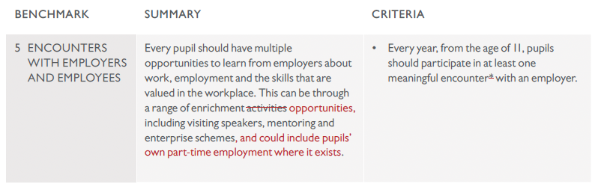
Development
This policy has been developed and is reviewed annually by the Careers Leader, Katie Martin and Line Manager/ headteacher, Fiona May based on current good practice guidelines by the Department for Education.
Links with other policies
It supports and is underpinned by key school policies including those for Careers, Child Protection, Equality and Diversity, and SEND.
Equality and Diversity
Access to other providers is available and promoted to allow all students to access information about other providers of further education and apprenticeships. The Rowans AP Academy is committed to encouraging all students to make decisions about their future based on impartial information.
Requests for access
Requests for access should be directed to Katie Martin, Careers Leader. Katie Martin may be contacted by telephone or email, katie.martin@therowansap.co.uk , Tel 01634 338803.
Grounds for granting requests for access
Access will be given for providers to attend during school assemblies, timetabled Careers or Life lessons, and Careers or Raising Aspirations events that The Rowans AP Academy is arranging. Students may also travel to visit another provider as part of the trip to be organised in partnership with The Howard Academy Trust.
Details of premises or facilities to be provided to a person who is given access
The Rowans AP Academy will provide an appropriate room or assembly hall to be agreed. All rooms have computers, projectors and screens provided. Computer rooms can also be arranged. The Careers Leader or Careers Adviser will organise this, working closely with the provider to ensure the facilities are appropriate to the audience. Appropriate safeguarding checks will be carried out. Providers will be met and supervised by a member of the Careers Team who will facilitate.
Live/Virtual encounters
The Rowans AP Academy will consider live online encounters with providers where requested, and these may be broadcast into classrooms or the school assembly hall. Technology checks in advance will be required to ensure compatibility of systems. However as a school we do recommend that provider attend in person as this is more meaningful for our pupils.

Parents and Carers
Parental involvement is encouraged, and parents may be invited to attend the events to meet the providers especially the annual careers fair.
Management
The Careers Leader coordinates all provider requests and is responsible to her senior management line manager.
Complaints Procedure
Any complaints about this policy should be raised to Katie Martin, email: katie.martin@therowansap.co.uk
Katie Martin will raise the complaint to Fiona May, Headteacher of The Rowans AP academy.
Any complaints with regards to provider access can be raised following the school complaints procedure or directly with The Careers & Enterprise Company via provideraccess@careersandenterprise.co.uk
Monitoring review and evaluation
The Policy is monitored and evaluated annually via the Senior Leadership Team.
Policy Coordinator: Katie Martin
Policy Reviewed: July 2025
Appendix
Providers who have been invited into The Rowans AP Academy to date include:
ALL Tasks scaffolding | The university of creative arts
Civil Service | Skanska
IPS international | Greenwich university
NACRO | National grid
MidKent college | Swale Skills Centre
Kent police | Sports Connect
NHS Trust | Superjam
McDonalds | The Electrical Academy
Wild Wood Media | Rivermead 6th Form

Destinations of previous pupils from The Rowans AP Academy include:
MidKent college Gillingham Apprenticeships with ALL Tasks scaffolding
MidKent college Maidstone
NACRO Chatham

Approval and review
Approved [date] by Governors at Curriculum and Standards Committee

Next review: [date]

Signed: [name] Chair of Governors

[name] Head teacher

