Mental Health and Wellbeing Policy
Policy Written/Reviewed by | Joanne Skinner
Date of Policy Review | September 2025
Date of Next Review | September 2026
Approval by Trust Board

Policy Statement
The Rowans’ mental health and wellbeing policy explains the school's commitment to its pupils' and staff’s mental health and wellbeing. It outlines how the school will support its pupils and staff, its ongoing commitment to staff training, and how it will work with the wider community to promote wellbeing.

Mental health problems frequently begin in childhood. There are clear links between the emotional wellbeing of children and young people, their personal and social development, and educational performance.

The Rowans recognises it has an integral role to play in supporting the mental health and wellbeing of its pupils, by developing approaches tailored to the needs of the pupils. All schools are under a statutory duty to promote the welfare of their pupils, which includes preventing impairment of children’s health or development and taking action to enable all children and young people to have the best outcomes.

Aims and Objectives
The Rowans’ role in supporting and promoting mental health and wellbeing can be summarised as:

• Prevention: creating a safe, calm and inclusive environment where mental health problems are less likely, improving the mental health and wellbeing of the whole school population, by equipping pupils to develop resilience so that they can manage the normal stress of life effectively. This includes teaching pupils about mental wellbeing through the curriculum and reinforcing this teaching through school activities and ethos.

• Identification: recognising emerging issues as early and accurately as possible.

• Early support: helping pupils to access evidence based early support and interventions and access to specialist support; working effectively with external agencies to provide swift access or referrals to specialist support and treatment.
The Rowans staff recognise that they cannot act as mental health experts and should not try to diagnose conditions. There are clear systems and processes in place for identifying possible mental health problems, including routes to escalate and a clear referral and accountability system. With auditable pathways this will enable pupils and staff to access relevant external support.
The policy aims to:
- Promote positive mental health in all staff and pupils
- Increase understanding and awareness of mental health issues
- Alert staff to early warning signs of mental ill health
- Provide support and training to staff working with pupils with mental health issues
- Provide support to pupils suffering mental ill health and their peers and parents or carers

Lead Members of Staff
All staff have a responsibility to promote the mental health of pupils and colleagues. Those staff with a specific role are:
- Mrs F May – Headteacher/DSL
- Mrs K Martin – Deputy Head/DSL
- Mrs J Skinner – Interventions and Mental Health Lead/DDSL
- Miss G Webb – SENCO/DSL
- Mrs R Jones – Attendance and Welfare Lead/DDSL
- Miss S Wheeler– PSHE teacher
- The Rowans Safeguarding Team
- The Rowans mental health first aiders

Any member of staff who has concerns about the mental health or wellbeing of a pupil, should contact the Interventions and Mental Health Lead or a member of the Safeguarding Team in the first instance. If a pupil is in immediate, imminent danger, a dynamic risk assessment will be carried out and the first aid procedures and or the safeguarding procedures will be implemented, including contact made with parents/carers and relevant external agencies, where appropriate.

Legal Considerations
- Under The Equality Act (2010) a person with a mental health difficulty is covered if their condition leads to an adverse impact on their ability to carry out their normal day-to-day activities. This will include pupils with conditions such as depression, bipolar disorder, self-harm and eating disorders.
- The Act also covers those who have had a mental illness or difficulty in the past, even if they have recovered, and those whose condition meets the definition but is successfully controlled by treatment (for example anti-depressants) or therapy.
- Under The Equality Act, it is unlawful to discriminate against pupils with a diagnosed mental health condition, and ‘reasonable adjustments’ may need to be made to ensure they can access education.
- Under the Data Protection Act (DPA and GDPR), all information regarding pupils with mental health difficulties is regarded as sensitive and personal information.
- Duty of Care - All staff need to be aware of the concept of the ‘Duty of Care’. This is a legal obligation which requires us to take reasonable steps to ensure the safety and well-being of all our pupils, staff and visitors.

Identifying Needs and Interconnected Tiers of Support
There are identification and measurement tools and frameworks used to support positive mental health and develop resilience. These contribute to the identification and early warning signs of mental health needs. It is the power of positive relationships and unconditional positive regard that is key to identifying when a pupil needs additional support.

Possible warning signs include:
- The pupil has told you there is a problem, for example, they have been feeling low or anxious recently
- Significant changes in the pupils’ appearance, for example: weight loss/gain, decline in personal hygiene, noticeable signs of self-harm
- Changes in mood, for example: mood is very up and down, miserable, tired, withdrawn
- Physical signs of harm that are repeated or appear non-accidental
- Changes in eating patterns or sleeping habits
- Concerns expressed from friends, family, other staff members
- Changes in behaviour, academic achievement or changes to friendship groups.
- Increased isolation from friends, family.
- Talking or joking about self-harm or suicide
- Abusing drugs or alcohol
- Expressing feelings of failure, uselessness or loss of hope
- Changes in clothing – e.g. long sleeves in warm weather
- Secretive behaviour
- Repeated physical pain or nausea with no evident cause

The Rowans has interconnected tiers of support to ensure that help is targeted and appropriate.

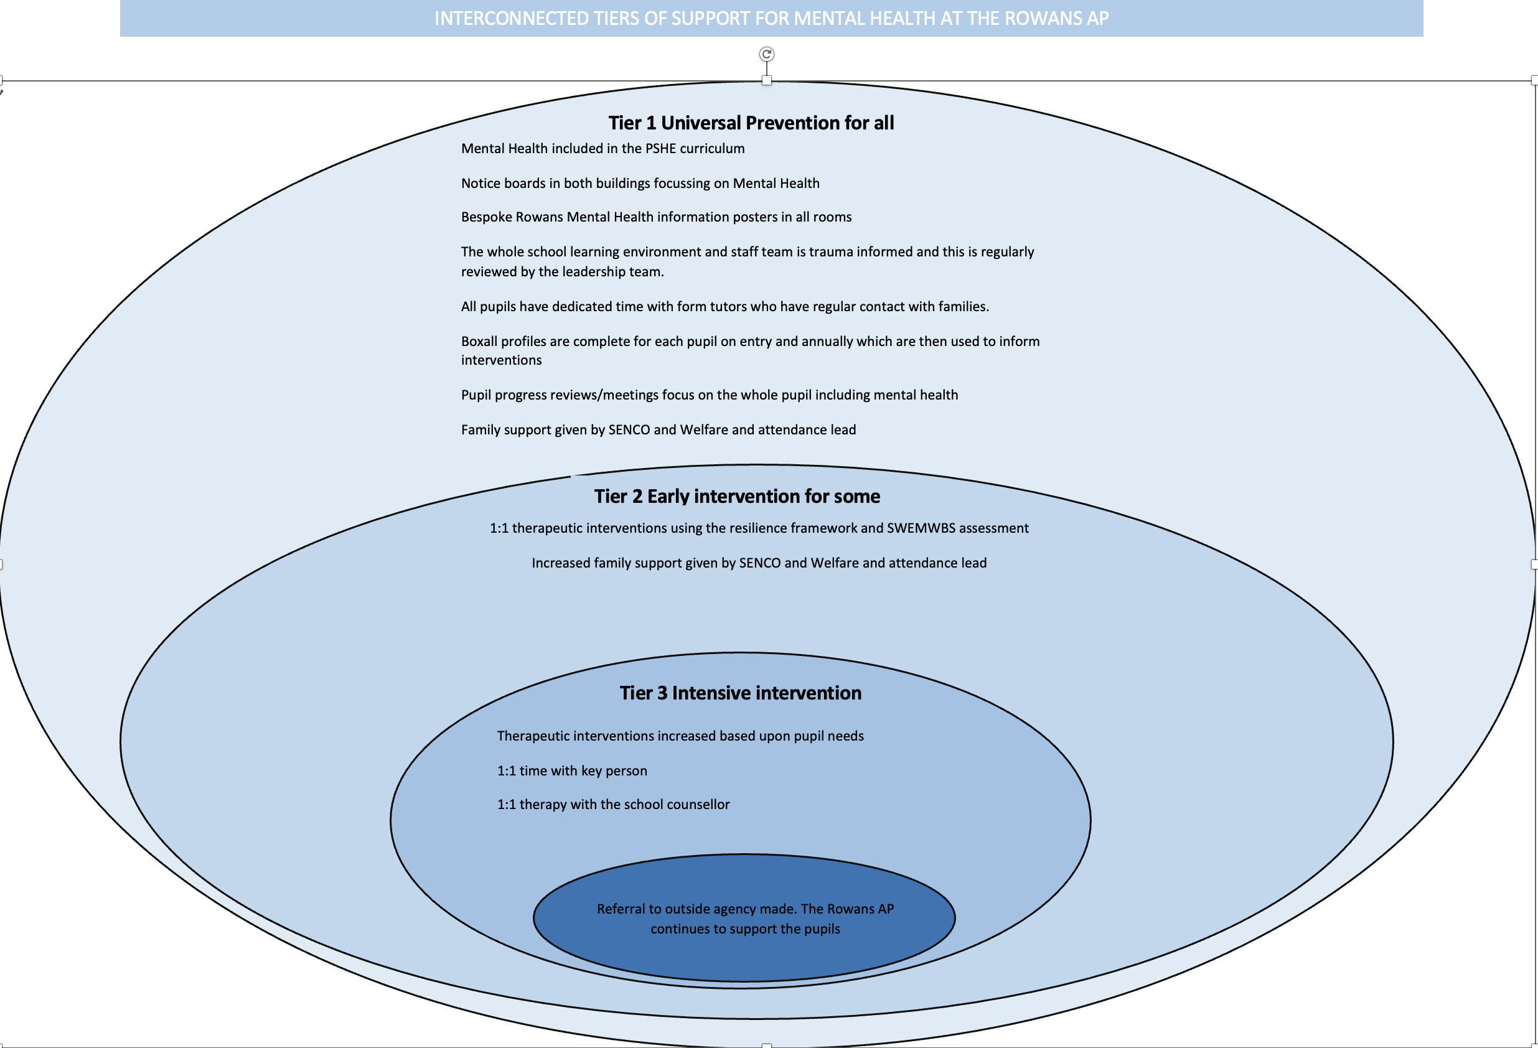

Managing and Reporting a Disclosure
A pupil may choose to disclose concerns about themselves or a friend to any member of staff, so all staff know how to respond appropriately to a disclosure. The process of managing and reporting a disclosure is the same as that for a safeguarding concern.

The member of staff’s response should always be calm, supportive, and non-judgemental if a pupil chooses to disclose concerns about their own mental health or that of a friend. Staff should listen rather than advise. First thoughts should be of the pupil’s emotional and physical safety rather than beginning to explore reasons. No member of staff will attempt to diagnose.
Managing disclosures is part of the staff induction process. All staff have relevant safeguarding training and all staff are aware of the reporting process in place for managing and supporting disclosures and safeguarding/mental health concerns.

All disclosures should be recorded in CPOMS. This record will include:
- Date
- The name and job role of the member of staff to whom the disclosure
was made
- Main points from the conversation
- Agreed next steps

This information will be shared with the mental health lead and the safeguarding team. The most appropriate member of the safeguarding team will take action, in line with the tiers of support, in consultation with the mental health lead.

Internal Support and Interventions
There are robust procedures in place to identify when a pupil requires additional support, including mental health needs. The interventions team deliver the majority of the internal interventions. The following are examples of interventions currently used with pupils who are experiencing mental health difficulties:
- Gardening
- Drawing and talking
- Cooking
- Lego therapy
- Counselling
- Emotional learning support/Wellbeing
- Emotionally available adult (advocate)

External Support and Signposting
Pupils experiencing mental health difficulties are often best supported jointly by home and school. There are various mental health charities who provide helpful information for parents, and who offer tools to assist young people with their mental health outside school. The Rowans website has a wealth of information to support both pupils and their families who are experiencing mental health issues.

The Rowans display relevant sources of support in communal areas of the school and regularly highlight sources of support to pupils within relevant parts of the curriculum as well as via home school communication. By maintaining the high profile of mental health and wellbeing we seek to increase the chance of pupils understanding:
• What help is available
• Who it is aimed at
• How to access it
• Why to access it
• What is likely to happen next

Creating a Safe and Supportive Learning Environment
- The Rowans creates a safe, calm and trauma informed environment where mental health problems are less likely, improving the mental health and wellbeing of the whole school population, and equipping pupils to be resilient to develop coping strategies for managing the normal stresses of life effectively.
- The Rowans teaches pupils about mental wellbeing through the curriculum and reinforces this teaching through school enrichment activities and its culture and ethos.
- Staff have opportunities to maintain positive emotional health and wellbeing, thus offering positive role modelling and sharing ways to live well and maintain positive emotional health & wellbeing.
Partnership Working
Pupils and parents/carers provide valuable input and insights into mental health issues. This process begins at the pre-admission meeting with the completion of the pupil profile document and a Boxall profile. Throughout the school year questionnaires seek views from pupils and parents/carers and areas for development are identified and acted upon.

Parents/carers are often very welcoming of support and information from the school about supporting their children’s emotional and mental health. In order to support parents/carers, we will:

• Highlight sources of information and support about common mental health issues on our school website
• Ensure that all parents/carers are aware of who to talk to, and how to go about this, if they have concerns about their child
• Make our mental health policy easily accessible to parents by sharing it on our website
• Share ideas about how parents/carers can support positive mental health in their children through our regular communication
• Provide school specific information leaflets for both pupils and adults containing information about mental health

Parents/carers and staff members may also struggle with their mental health. Caregiving and teaching can both be emotionally demanding jobs and it is important to ensure that care is taken around personal wellbeing. The Rowans promote the importance of self-care and actively encourage the staff to maintain a healthy work life balance.

Training and Continuing Professional Development
All staff will receive regular training about recognising and responding to mental health issues as part of their regular child protection training to enable them to keep pupils safe. Key members of the staff team have Mental Health First Aid training at a minimum. Training opportunities for staff who require more in-depth knowledge will be considered as part of the performance development process and additional CPD will be supported throughout the year.

UN Convention on the Rights of the Pupil
This policy takes into consideration the following Articles:

Article 3 - The best interests of the child must be a top priority in all decisions and actions that affect children.

Article 12 - Every child has the right to express their views, feelings and wishes in all matters affecting them, and to have their views considered and taken seriously. This right applies at all times, for example during immigration proceedings, housing decisions or the child’s day-to-day home life.

Article 29 – Education should develop each pupil’s personality to the full. It should encourage pupils to respect their parents, and their own and other cultures.

Article 39 - Children who have experienced neglect, abuse, exploitation, torture or who are victims of war must receive special support to help them recover their health, dignity, self-respect and social life.

