Improving Staff Wellbeing and Reducing Teacher Workload Framework

The Rowans want staff to feel valued. The Rowans leadership team actively listen to staff and respond appropriately and quickly to develop systems and processes that promote a healthy work life balance and reduce staff workload. This document has been developed in consultation with staff and informed by the Making Data Work report from the Workload Advisory Group, independent reviews of marking, planning and data management, and Improving Teacher Happiness and Wellbeing, a collection of expert resources from IRIS Connect.

Teacher wellbeing is a crucial factor in achieving school success and one which is given high priority at The Rowans AP Academy. A research study into the links between staff wellbeing and school performance concluded that:
- How teachers feel on a daily basis is likely to affect their performance and, in turn, the performance of the pupils they teach.
- Happier, motivated teachers may make pupils feel happier, motivated and more confident.
- Happier teachers may also be able to concentrate better on the job of teaching and experience more motivation to help pupils in need of special attention.
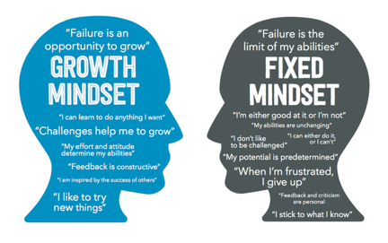
Self-efficacy is the extent to which an individual feels able to complete tasks and reach goals; being self-efficacious is similar to thinking with a growth mindset, it is also essential to happiness and to a sense of wellbeing. A teacher with a strong sense of self-efficacy is more likely to:
- Feel confident in choosing the best approach to suit the needs of their classes and individual pupils.
- Be adaptable and resilient when faced with challenge or change.
- Engage in enquiry and research within their role and feel secure enough to share this with others.
- Feel able to work collaboratively and contribute to school improvement.

The Rowans AP Academy is committed to supporting all staff professionally and personally, recognising that staff are more effective and efficient when they feel happy and fulfilled. The academy regularly seeks the views of staff through daily staff briefings, surveys, and one-to-one conversations with the Leadership Group. There is a clear focus on staff wellbeing and on reducing teacher workload, both of which are priorities within the School Improvement Plan.

Outcomes from a staff survey highlight that there are many areas of daily school life that staff consider appropriate in terms of the time spent on them. These include;
- Individual planning and preparation of lessons, both in and out of school
- Teamwork and professional dialogue with colleagues
- Pupil supervision and tuition outside of timetabled lessons
- Communication and co-operation with parents and carers
- Appraising, monitoring, coaching, mentoring, and training other staff

The survey also identifies areas where staff feel improvements are needed;
- Pupil counselling, including individual care and careers support
- Cover for absent colleagues during the school day
- Recording, inputting, monitoring, and analysing data relating to pupil performance and other purposes

In response, The Rowans AP Academy employs a school counsellor who works with pupils on a one-to-one basis for a minimum of six weeks. The academy introduced task and finish groups, including a Careers and Aspirations group, who ensure that careers support for Year 11 pupils is addressed, reducing the additional workload that is often placed on form tutors. Members of this group mentor Year 11 pupils and support them in securing appropriate post-16 pathways.

Wherever possible, the cover supervisor/HLTA and the Leadership Group provides cover for absent colleagues within the school day. To further reduce workload, teacher data drops are limited to three per academic year instead of six, and traditional parents’ evenings are replaced with two Academic Review Days a year. In line with Making Data Work (2018), staff performance development targets are not linked to quantitative assessment or progress data.
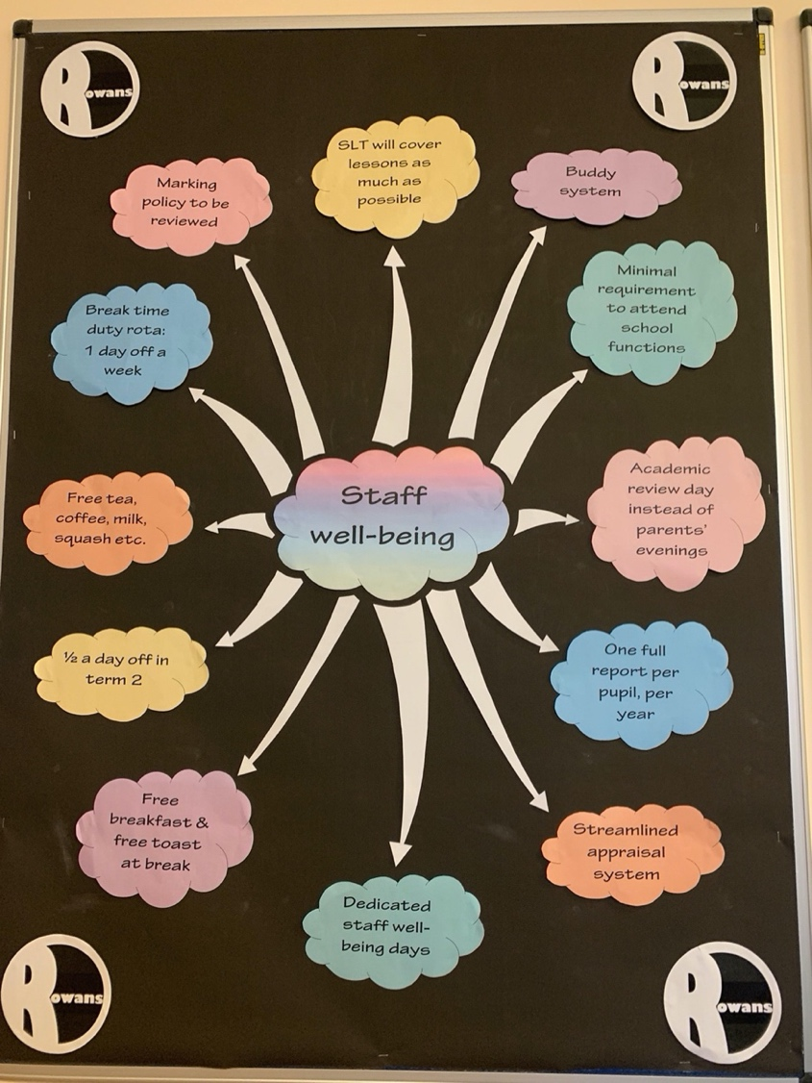
The Rowans AP Academy is committed to promoting staff wellbeing, and a range of initiatives are in place which are regularly reviewed and refined.
A buddy system operates across the school, encouraging staff to “look out for” a colleague or small group of colleagues. This system is intentionally informal, with no set expectations, allowing staff to engage in ways that feel natural. Many colleagues choose to support one another through small gestures such as leaving treats or positive notes.
Staff wellbeing is further supported through the provision of complimentary refreshments, including coffee, tea, milk, sugar, and squash, which are available to all staff at no cost.
All staff have access to a free breakfast each day as part of the school’s Breakfast Club offer, and they are also able to enjoy complimentary toast or fruit at break time. While all staff are required to be on duty during break times, a rota system has been introduced to ensure that each member of staff receives one duty-free break per week.
During Term 2, all staff are allocated half a day off for Christmas shopping, recognising the additional pressures at this time of year. Throughout the year, the academy also runs staff wellbeing days, during which specific initiatives and treats are trialled and evaluated to inform ongoing improvements.
To further support mental health and wellbeing, each member of staff has been provided with a self-care ‘going-home’ checklist, encouraging healthy work-life balance and reflective practice. Which is included below. In addition, the academy maintains a staff wellbeing offer, collating a range of additional benefits available to educational staff. These are outlined at the end of this document.
Teacher workload is a significant issue nationally and one which The Rowans AP Academy is continually addressing by reviewing processes, procedures and expectations and seeking new and innovative ways of working, whilst maintaining high standards and best possible outcomes for pupils.

The Rowans AP Academy have made changes to reduce teacher workload. These include;
- Using Technology Effectively – introduced CPOMS for safeguarding concerns. The use of an ‘@safeguarding’ email for all safeguarding information to be shared within the safeguarding team. Weekly pupil reports are now emailed to parents/carers. Using CANVA to reduce time in producing visual data graphics from data, for data reports.
- Curriculum Planning – There has been a change in timings so the whole academic year’s planning does not need to be done at one time. Teachers are expected to produce medium term plans for each term, in advance of the term, which fit into their overall curriculum intent and sequencing documents.
- Data Management and Pupil Intervention – data collection points have been streamlined to 3 per academic year, with all data collation being done by the Senior ICT technician. Progress data is presented back to the staff in a more useable format for pupil progress meetings with agreed actions decided. The Rowans AP Academy have introduced an Annual Performance Report which is shared with the Governors. There is a dedicated interventions team who implement structured and evidence-based interventions, therefore having no impact on teacher time.
- Communications – The Rowans AP Academy is clear about expectations for internal communication with staff, which are set out in the staff handbook. All staff use a consistent email signature which states, “As a school we strive to ensure the well-being of our students, families and staff. As such, please note that during evenings, weekends and holidays staff are not normally on duty, so emails will be responded to at the earliest opportunity.” Following a review of attendance and effectiveness, the academy now operates two Academic Review Days per academic year in place of traditional parents’ evenings. Members of the Leadership Group, the SENCo, and the Welfare and Attendance Lead are issued with work mobile phones. Text messaging is used where appropriate to communicate with parents and carers, in recognition that this is a preferred method of communication for many families. In addition to The Rowans AP Academy Facebook account, there is also an and Instagram account, which are used to share key information and celebrate pupil achievements and wider school successes with pupils and parents.
- Managing Change – there is a shared school calendar which is produced in advance of the new school year. Term dates are decided and shared a year in advance. All after school commitments are shared with the staff and timely reminders sent via email.
- Performance Development – the Performance Development process at The Rowans AP Academy is designed to improve and sustain high-quality inclusive teaching through a strong focus on continuous professional development. Pay progression is not dependent on quantitative assessment data. Evidence gathering is proportionate, with staff collecting ongoing evidence through everyday practice, CPD participation, and professional dialogue.
- Managing Behaviour – The behaviour, relationships and inclusion policy is streamlined, to encompass inclusion and trauma-informed practice. The day sheet used promote the school’s values. There is an after-school rota to ensure that where pupil supervision is needed this is a shared responsibility, with teachers only needing to be ‘on call’ once every two weeks. There is a limited word count on Arbor for behaviour logs to further reduce workload.
- Teaching Assistant Support – All practical subjects have a dedicated teaching assistant who can support with preparation and resourcing. They have increasingly specialist knowledge and skills in the subjects they support in.

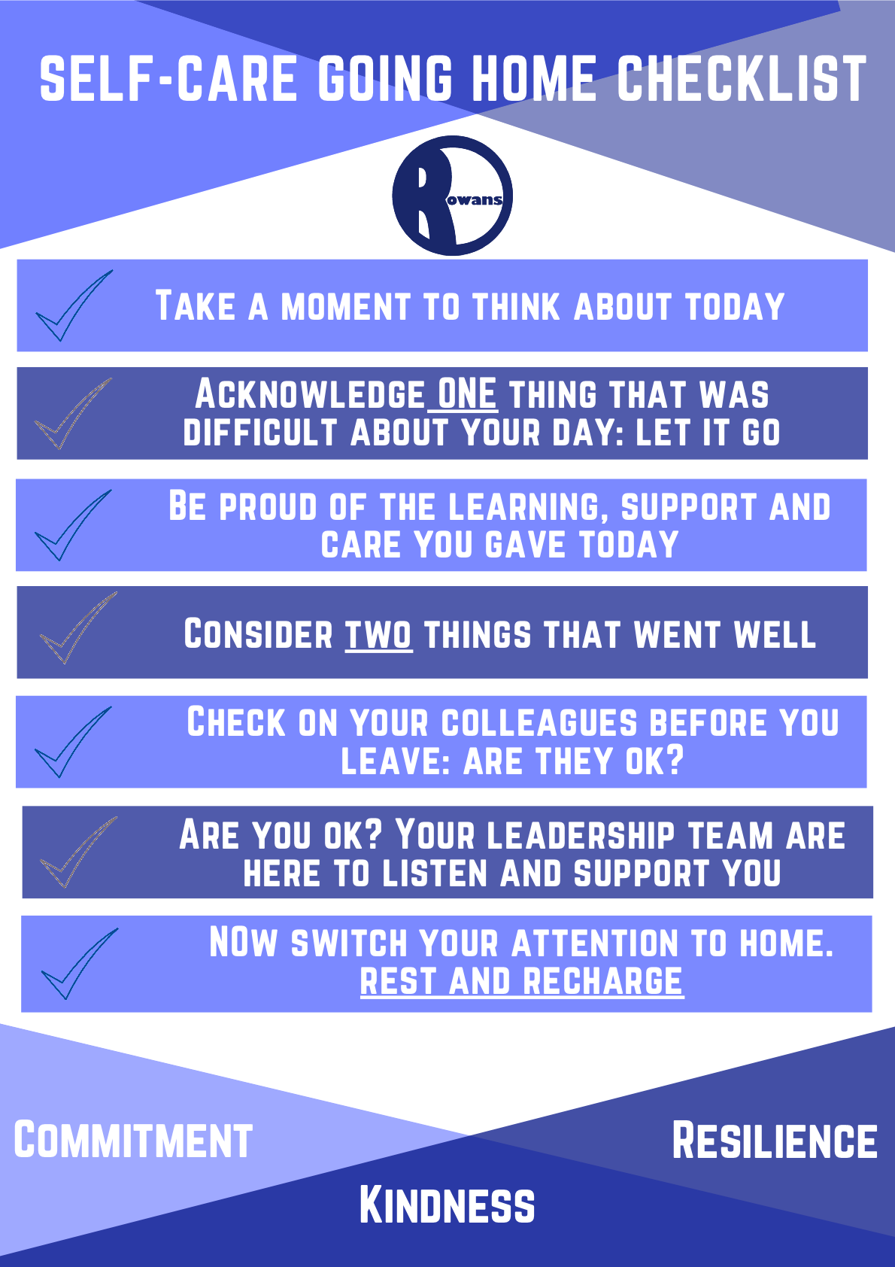

The Rowans staff wellbeing offer and processes

5 tips for feeding your senses!
- Sight - revisit the Display Screen Equipment Self Risk Assessment if you feel your needs for working with a display unit has changed. You can also use your blue light discount to get discounted eye tests and glasses.
- Sound - add music to compliment your lessons and transitions to create a calm environment.
- Smell - use the free drinks/soups in the staffroom to feed your sense of smell with good things
- Taste - use the toast/snack provision at breaktimes.
- Feel - feel comfortable, use the staff wellbeing items in the toilets

The Rowans Staff Health and wellbeing strategies
At The Rowans we operate to sustain staff wellbeing and reduce stress. We have;
- developed a buddy system to support staff during periods of higher workload
- adopted an open-door policy to ensure everyone feels heard and seen
- built-in end of day meetings to reflect on the day and debrief. This also supports positive communication across all areas.
- a robust CPD programme to provide all staff with opportunities to continue to grow professionally.
- a mentoring menu to support staff in developing their practice
- a going home checklist to support transition after work
- Wellbeing Wednesdays once a term
- offered funding for flu jabs and health checks

THAT Staff Health and wellbeing policies and resources (click here for direct link)
Policies
- THAT Family Friendly Policy – for family linked leave
- THAT grievance procedure
- THAT Health and Safety policy
- THAT Health and Wellbeing policy (including Display Unit self-risk assessment)
- THAT Pay policy – includes information about accessing early pay
- THAT preventing Sexual Harassment at work policy
- THAT right to apply for flexible working policy
Resources
- Benenden Health scheme for staff
- Employee Substance misuse support
- Mental Health Toolkit
- Stress awareness
- THAT staff benefits (including discounted gym membership and reduced eye care costs)
- Wisdom App. – To support health and mental wellbeing.


To access this wellbeing offer and links electronically scan the QR code


Additional benefits to access for education-based staff
Blue Light Card   | ● Paid service - £4.99 for 2 years  ● Personal login can be used, but school email will need to be confirmed
Discounts for teachers   | ● Free to join for all staff - need to use school login  ● You will need to set up a login for this  ● Offer a range of discounts across many retailers (sometimes vouchers need to be brought for this)
Teacher Perks   | Free membership for school staff and schools to access incredible perks from high street brands and edu-suppliers.  There are also lots of free downloadable resources too!  ● Free to join  ● You will need your work email
Manic Street Teachers   | Some free downloadable resources for KS2 mainly to help reduce workload.
The School Trip   | ● Free to join  ● Login will need to be set up with a school login  ● Lottery for theatre tickets applied for  ● Can apply for as many as you like  ● Win up to 2 tickets per entry
O2 open   | Complete the verification process via the Open portal, and then sign in again to add the discount.
EE 20 discount for key workers  | To get the discount, you'll need to sign up and verify your employment with Beans ID to get a discount code. You can then browse available eligible phone plans and enter your code at the checkout. The discount's only available online, not via EE's contact centres or high-street shops.
Apple Education store   | To order online, go to the Apple Education Store* website and select which product you're interested in. You'll then be asked to sign up (or log in) to the discount scheme Unidays using your uni or education workplace email address for verification. The education discounts should then be automatically applied. If you're unable to sign up to Unidays or you don't want to give it your data, you can call Apple on 0800 048 0408 and it'll verify you with your ID or acceptance letter and you can continue your purchase over the phone.  Alternatively, go to an Apple Store (find your nearest*) and show your ID card, letter of acceptance or payslip.
Hilton Hotels | Hilton Hotels offer a 30% discount on their flexible rate, for most of their UK and European hotels, to all public sector workers, including teachers. Once on the Hilton website, you can find the "have a special code?" link and enter the code PR11PN, which will get you 30% Hilton hotels discounts for teachers.
International Teacher Identity Card   | ● Up to 40% off flights and 5% off travel insurance with STA Travel.  ● Thousands of benefits worldwide on accommodation, all the way through to transport, with discounts on entertainment, food and travel too  ● Access to fantastic discounts at home and abroad  To get an International Teacher Identity Card, you need to present a letter on official school or university stationary confirming that you are employed at a recognised educational establishment for a minimum of 18 hours per week and for a minimum of one academic year. As well as this, you'll also need to present one of the following and a passport sized photo:  ● Passport  ● Birth Certificate  ● An official identity card issued by the official authorities  Cost - The price of a Virtual ITIC card is £12 (+£3 for a plastic card)  Validity - 12 months from the date of issue.
Headspace   | Mindfulness and meditation app Headspace is offering free subscriptions to primary and secondary school teachers and supporting staff.  You'll need to provide the name of your school and work email address, as well as a form of documentation proving your employment.

