A Framework For Inclusivity through Anti-Racism Practice at The Rowans


The Rowans AP Academy recognises the need for and prioritises a sense of belonging for all pupils and staff. The staff model kindness and acceptance of everyone at The Rowans, ensuring every child is included and given the opportunity to access education fairly in line with their peers, regardless of their heritage and culture.
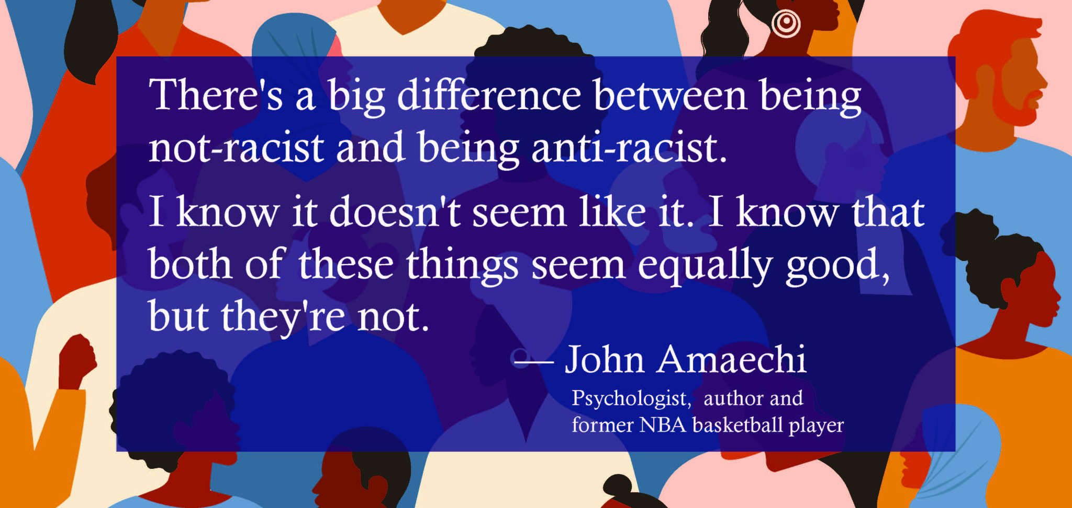

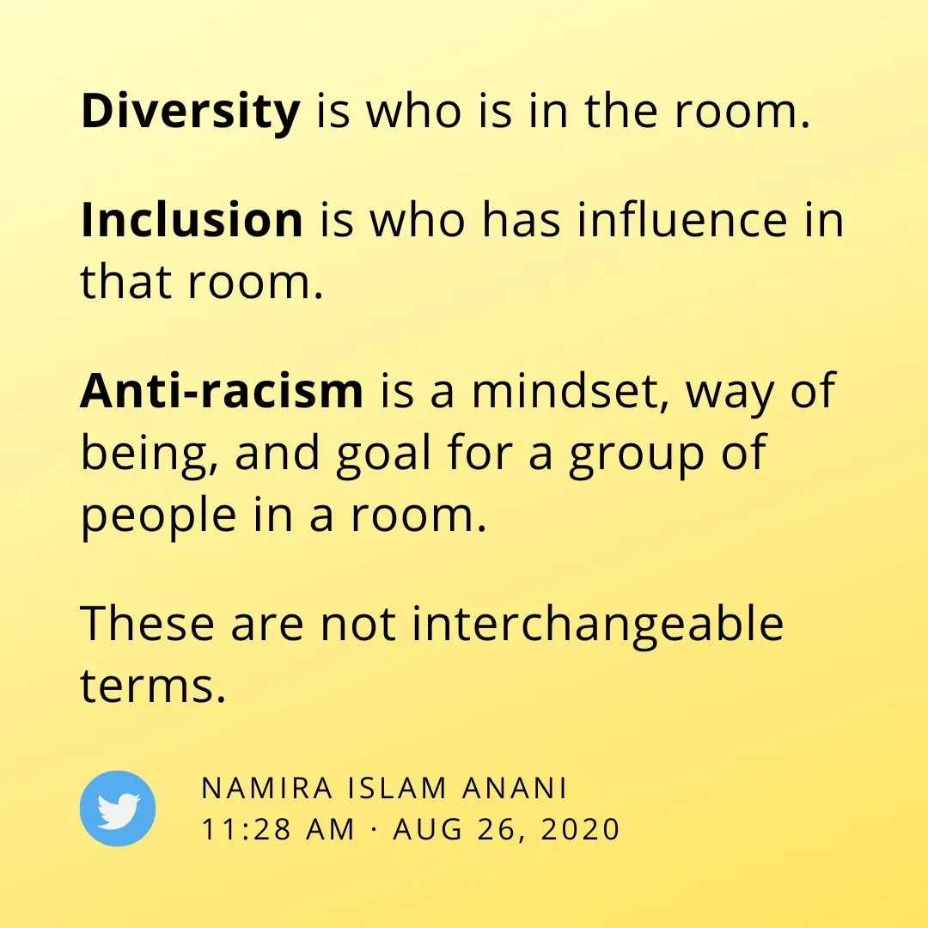
Diversity & Inclusivity vs anti-racism
The Rowan’s approach towards Anti-racism is embedded in a proactive and positive mindset towards inclusivity for all. This approach promotes the integration of diversity across the curriculum, helping children understand how a range of perspectives shape the world around them while also challenging and dispelling common stereotypes. Through this approach the basis of an anti-racism mindset is developed and built upon.

The Rowan's values of Kindness, Commitment and Resilience play a big role in educating children around anti-racism, alongside ‘living’ our vision statement of ‘We see you, we hear you, we are with you’.

Kindness - treating everyone with dignity, empathy, and respect, regardless of race or background.
- Encouraging children to listen to and value others’ experiences, especially those different from their own
- Modelling inclusive language and behaviour, ensuring no one feels excluded or marginalised
- Challenging hurtful comments or stereotypes in a calm, supportive way, helping children understand why kindness matters
- Promoting friendships and collaboration across cultures to build mutual understanding
Kindness helps create a safe environment where differences are seen as strengths rather than barriers.
Commitment to anti-racism means taking consistent, intentional action rather than treating equality as a one-off topic.
- Embedding diverse voices, histories, and cultures throughout the curriculum—not only during special events
- Following inclusive policies and actively addressing discrimination whenever it occurs
- Continuing personal and professional learning about race, bias, and social justice
- Showing children that fairness and equality are ongoing responsibilities
This commitment demonstrates that anti-racism is a shared, long-term value rather than a temporary initiative.
Resilience in anti-racism involves perseverance—standing against racism even when it is challenging or uncomfortable.
- Supporting children to speak up against unfairness and learn from mistakes
- Teaching that it is okay to ask questions, reflect, and grow from misunderstandings
- Addressing racism proactively, even if it requires difficult conversations
- Encouraging confidence and self-worth in children from all racial and cultural backgrounds
Resilience ensures individuals and communities continue striving for justice, even when progress feels slow.

What does Inclusivity through Anti-Racism Practice at The Rowans AP Academy look like?
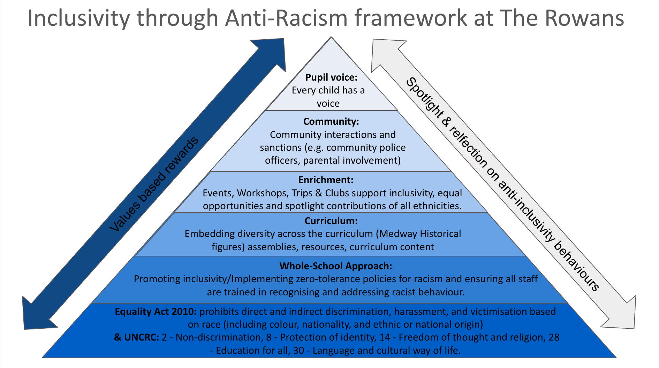
The Rowan’s use the framework above to support the anti-racism approach to support inclusivity, which demonstrates the different layers that are planned for and built upon to develop a racially inclusive learning environment. This starts with the Equality Act 2010 and many parts of the UN Convention of the Rights of the Child. The whole school approach supports policies, staff training, as well as the pedagogy around the teaching to develop an anti-racist mindset. There are links made within the taught curriculum to local diverse historical figures to support a balanced representation of people that have contributed to local life. Enrichment activities, community links and pupil voice are developed to support the 5 Fundamental British Values (laid out below) which uphold an inclusive and anti-racism mindset.


Reflecting on racist language and behaviours at The Rowans AP Academy
The framework for inclusivity through anti-racism builds on and rewards positive behaviours and interactions for everyone at the school. In the event that there are racist incidents at The Rowans, the children are encouraged to reflect on why they have behaved in that way, to support them in understanding their behaviours and actions. The tool below can be used to support these reflective and restorative discussions following inappropriate behaviours. There is an adapted visual one available for SEND and younger children at The Rowans AP Academy.

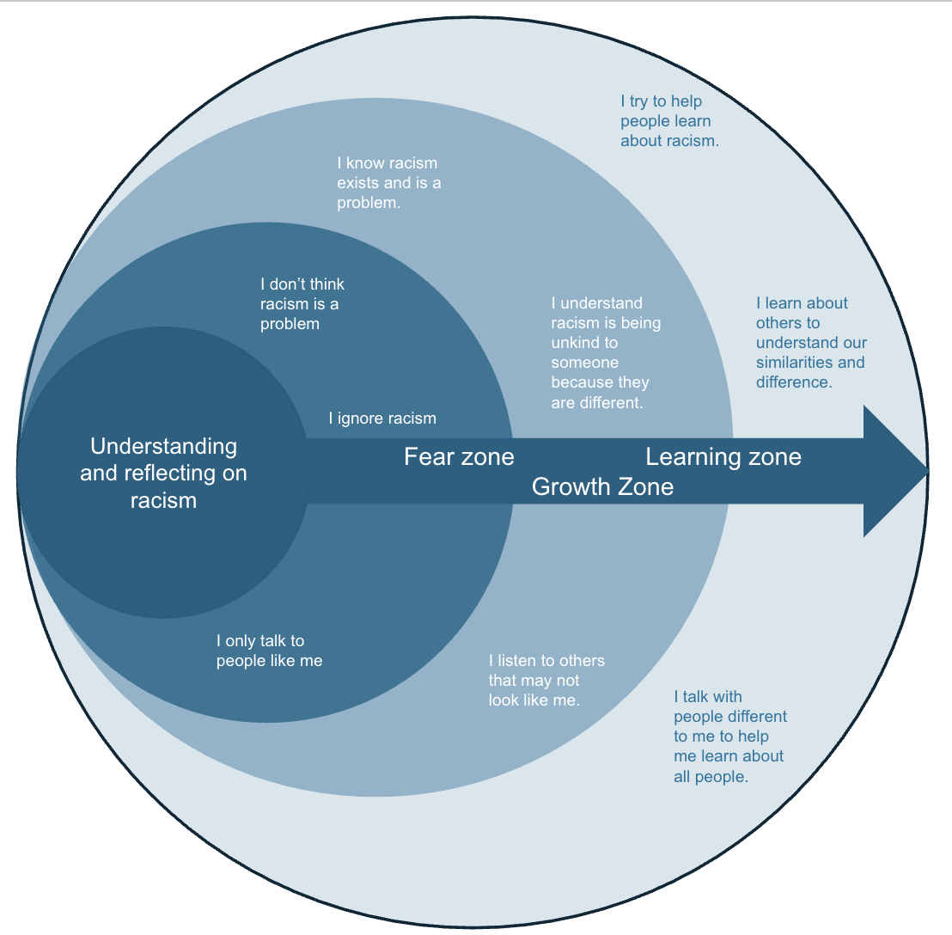
Understanding and reflecting racism, created by The Rowans May 2026.

Based on “Anti-racism self-reflection zones” (https://anpedi.org/anti-racist/ - 13/04/2026)

