
Improving Staff Wellbeing and Reducing Teacher Workload Framework

This document was developed following consultation with the staff and in response to ‘Making data work’ report from the Workload Advisory Group and independent review groups on marking, planning and data management. It also considers information from ‘Improving Teacher Happiness and Wellbeing’, a collection of expert resources by IRIS connect.

Teacher wellbeing is a crucial factor in achieving school success and one which is given high priority at The Rowans AP Academy. A research study into the links between staff wellbeing and school performance concluded that:
- How teachers feel on a daily basis is likely to affect their performance and, in turn, the performance of the pupils they teach.
- Happier, motivated teachers may make pupils feel happier, motivated and more confident.
- Happier teachers may also be able to concentrate better on the job of teaching and experience more motivation to help pupils in need of special attention.
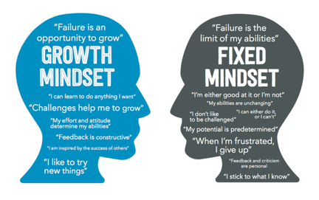
Self-efficacy is the extent to which an individual feels able to complete tasks and reach goals; being self-efficacious is similar to thinking with a growth mindset, it is also essential to happiness and to a sense of wellbeing. A teacher with a strong sense of self-efficacy is more likely to:
- Feel confident in choosing the best approach to suit the needs of their classes and individual pupils.
- Be adaptable and resilient when faced with challenge or change.
- Engage in enquiry and research within their role and feel secure enough to share this with others.
- Feel able to work collaboratively and contribute to school improvement.

The Rowans AP Academy is committed to supporting all staff professionally and personally, recognising that they are more effective and efficient when they are happy and fulfilled. The Rowans AP Academy regularly seeks the views of the staff via; the daily staff briefing, surveys and 1:1 conversations with the Leadership Group. There is a focus on staff wellbeing and reducing teacher workload, both of which are on the school improvement plan.

Outcomes from a staff survey in March 2019, highlighted that there were many areas of daily school life that staff considered appropriate in terms of time spent on them, this included:
- Individual planning and preparation of lessons at school or out of school
- Team work and dialogue with colleagues within school
- Pupil supervision and tuition outside of timetabled lessons
- Communication and co-operation with parents or carers
- Timetabled tutor time and related activities
- Appraising, monitoring, coaching, mentoring and training other staff.

Areas where staff felt that improvements needed to be made were:
- Pupil counselling (including individual care and careers support)
- Cover for absent colleagues within the school day
- Recording, inputting, monitoring and analysing data in relation to pupil performance and for other purposes

In response to these areas, The Rowans AP Academy have employed a school counsellor who sees pupils on a 1:1 basis for a minimum of 6 weeks. The Academy have introduced working parties for 2019/2020, one of which is ‘careers and aspirations’, this means that careers support for Year 11 can be part of the working party actions, limiting the careers work usually done by the from tutors. All members of the working party are mentoring Year 11 pupils, ensuring they have an appropriate post 16 pathway. The Leadership Group, where possible, will do any daily cover for absent colleagues. The data drops for teachers have been reduced from 6 to 3 over an academic year, parents’ evenings have been replaced by one Academic Review Day and in line with ‘Making Data Work’ (2018), staff no longer have performance development targets linked to quantitative assessment or progress data.

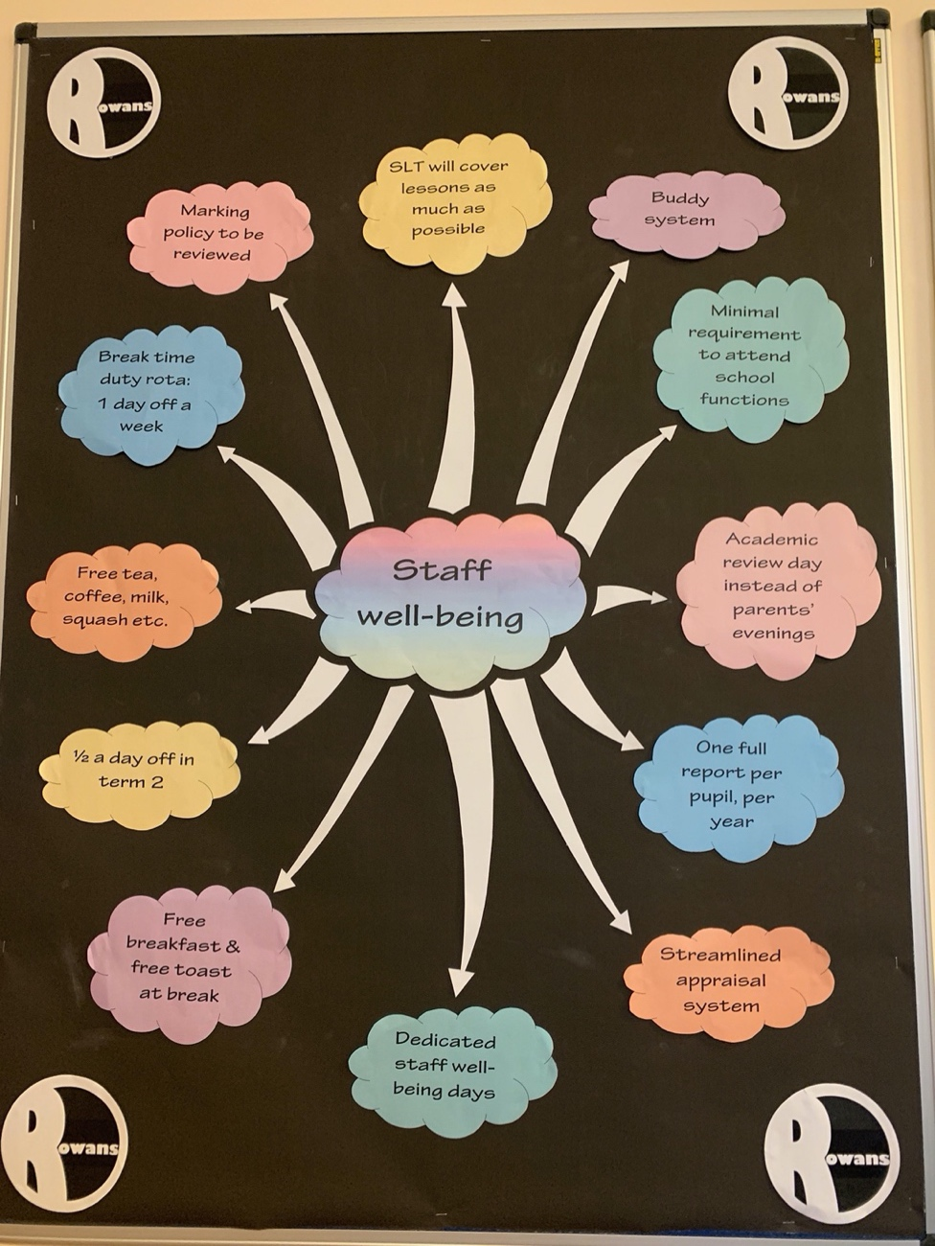
There are many staff well-being initiatives at The Rowans AP Academy and these are being continually reviewed. These include: a buddy system where staff ‘look out for’ a colleague or small group of colleagues. There is no expectation or formality to the buddy system, although many have been leaving treats for each other or positive notes. Staff have coffee, tea, milk, sugar and squash all provided for them, without charge. In term 2, each year staff are given half a day off for Christmas shopping. All staff have access to a free breakfast each day as part of the Breakfast Club offer and they also have the opportunity to have complimentary toast or fruit at break time. All staff are on duty at break time, however, there is now a rota giving each member of staff one day off the rota per week. Spread throughout the year there are also staff well-being days where specific treats and initiatives are trialled and evaluated. Each member of staff has been issued with a self-care going home check list to support their mental health and well-being.

Teacher workload is a significant issue nationally and one which The Rowans AP Academy is continually addressing by reviewing processes, procedures and expectations and seeking new and innovative ways of working, whilst maintaining high standards and best possible outcomes for pupils. The Rowans AP Academy have made changes to reduce teacher workload. These include:
- Using Technology Effectively – use of an ‘@safeguarding’ email for all safeguarding concerns to be reported. Where possible, weekly pupil reports are emailed to parents/carers. Using SIMS Discover to reduce time in producing visual data graphics from SIMS.
- Feedback and Marking – the marking policy has been reviewed with a change from prescriptive marking to feedback techniques which are proportionate and appropriate in supporting pupil progress.
- Curriculum Planning – There has been a reduction in expectation. Teachers are expected to produce medium term plans for each term, in advance of the term, which fit into their overall curriculum intent and sequence documents.
- Data Management and Pupil Intervention – There has been a reduction in data collection points to 3 per academic year, with all analysis being done by the Senior ICT technician. Progress data is presented back to the staff in a more useable format for pupil progress meetings with agreed actions decided. The Rowans AP Academy have introduced an Annual Performance Report which is shared with the Members and Trustees. The Rowans AP Academy now have a dedicated Interventions Team. All interventions are evidence based, structured interventions delivered by the dedicated team, therefore having no impact on teacher time.
- Communications – The Rowans AP Academy are clear about internal communications for staff, with expectations in the staff handbook. The staff all have the same email ‘signature’ which states that, “As a school we strive to ensure the well-being of our students, families and staff. As such please note during evenings, weekends and holidays staff are not normally on duty so emails will be responded to at the earliest opportunity.” After reviewing the attendance to and effectiveness of parents’ evenings, we now have one Academic Review Day per academic year. Staff in the Leadership Group, the SENCo and the Welfare and Attendance Lead have all been issued with a work mobile phone. Texts are used, where appropriate, to communicate with parents, as it has been recognised that this is a preferred way of communicating for many parents and carers. As well as having a Twitter Account, The Rowans AP also have a Facebook Account to share information and pupil and school successes with pupils and parents.
- Managing Change – there is a shared school calendar which is produced in advance of the new school year. Term dates are decided and shared a year in advance. All after school commitments are shared with the staff and timely reminders sent via email.
- Performance Management – this has been completely changed with a new system in place. The newly designed ‘Performance Development’ process is less onerous and puts improving and maintaining the highest quality of teaching at the heart of all processes with a genuine focus on continuous professional development. All staff share the same focus for one target, based on research informed practice to improve teaching and learning, and therefore, outcomes for pupils. The second target is linked to their specific role within the working party. All working parties focus on a specific target taken directly from the School Improvement Plan. The new system ensures that pay progression is not dependent on quantitative assessment data. Evidence gathering is now proportionate for all staff, as the new performance development system means that staff collect evidence as the year progresses, combined with CPD information and evidence.
- Managing Behaviour – The behaviour policy has been streamlined, combining inclusion and trauma-informed practice. The day sheet has also been adapted to promote the school’s values. There has been an after-school rota created to ensure that where pupil supervision is needed this is a shared responsibility, with teachers only needing to be ‘on call’ once a week. There is a limited word count on SIMS for behaviour logs to further reduce workload, with the majority of the form being drop down menus for quick selection.



