A Framework For Trauma Informed Practice at The Rowans

As a trauma informed school, The Rowans AP Academy prioritises a sense of belonging for all pupils and staff. The staff model the power of relationships and attachment for all pupils, acknowledging that “every child deserves a champion”. Building positive relationships with pupils, especially those with limited social and emotional skills, is a professional duty of all staff at The Rowans AP Academy. It requires commitment, emotional regulation, empathy and unconditional positive regard.

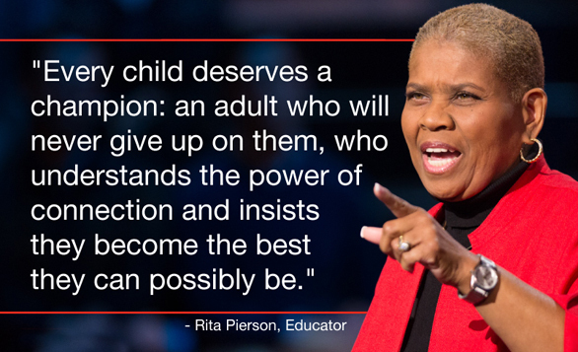

What are ACEs?
Adverse Childhood Experiences (ACEs) are highly stressful and potentially traumatic, events or situations that occur during childhood and/or adolescence. There are nationally recognised ACEs:
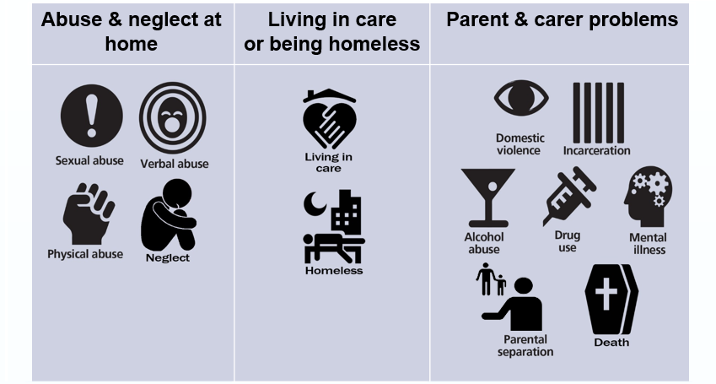

At The Rowans AP Academy, we record pupils’ vulnerabilities, using our own vulnerabilities index and this information is used to identify additional support that pupils may need or referrals made to specialist services. In addition, an ACEs index records any information shared by the pupil, whilst at The Rowans. This is not a checklist and it is recognised that pupils may not share their ACEs. Where this information is voluntarily shared, it is recorded and used to support the individual pupils, through therapeutic interventions, 1:1 counselling or specialist support from external partners or specialist services.

The Rowans AP Academy recognise that ACEs directly affect pupils and their environment and require significant social, emotional, psychological or behavioural adaptation. The impacts of childhood trauma are serious and can affect many areas of a pupil’s life, as shown in the diagram below:
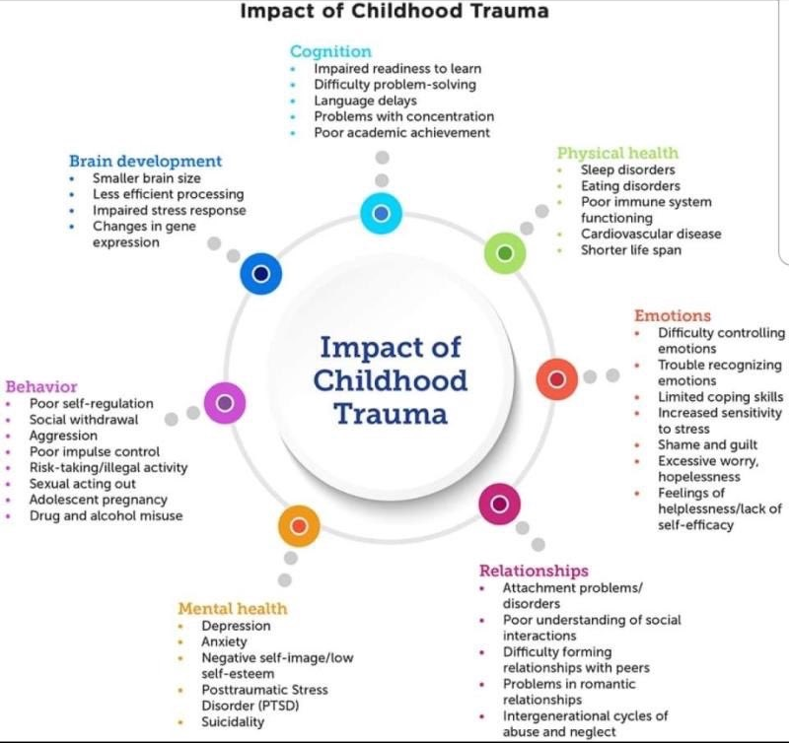

What does being trauma informed mean at The Rowans AP Academy?
Trauma informed practice at The Rowans AP Academy exists within the Behaviour and Inclusion Policy and alongside the school values of kindness, commitment and resilience. The behaviour and Inclusions Policy provides a framework in which there is an understanding of attachment and trauma, extending our knowledge and response to adverse childhood experiences so that pupils can heal, thrive, learn and make progress. All staff will work hard to be consistent in the application of the policy, keeping clear boundaries and maintaining high expectations thus promoting trusting and mutually respectful relationships.

The Rowans operates within a trauma-informed approach, where there is a recognition that pupils are emotionally de-regulated, staff support pupils to regulate, often through co-regulation, then relationships are re-established through reconnection. Part of this process will also be to remind the pupils that there will be a consequence for their choice of behaviour. Strategies for supporting pupils displaying challenging behaviours and displays of anger, are based on: an understanding of the functioning and development of the brain, the reminders of the link between choices and consequences, the role that trauma and adverse childhood experiences has on development and the importance of an emotionally available adult to support with the 4Rs – Recognise, Regulate, Reconnect and Restore.

Wherever possible, The Rowans will seek a restorative approach to all incidents. This process does not assign blame but encourages the pupils to look at their own and others’ behaviours with a view to providing a positive outcome for all involved. Following an incident, the pupil/s and their parent/carer are invited to a meeting at which it is decided whether the Restorative Approach should be offered.

Trauma-informed practice for The Rowans AP Academy means:
- Building and maintaining positive relationships
- Having the confidence and ability to own your own mistakes in front of the pupils – allowing them to feel safe when they make mistakes
- Knowing the individual pupils and the contextual information in their background
- Being emotionally available to pupils
- Sharing what trauma is with the pupils so that they are self-aware
- Using more trauma-informed appropriate language to help the child understand
- Important that the pupils are not blamed for their ACEs
- Modelling healthy relationships
- Opportunity to access therapeutic interventions and counselling
- Empowering pupils, giving them control where and when appropriate
- Clear and firm boundaries in place
- Taking care of yourself and your colleagues
- Having the time to reconnect with pupils and help heal hurt

The Rowans’ 4 Rs:

At The Rowans we are trauma-informed
We connect before we correct
We stay curious not furious
We understand behaviour is communication
We believe in co-regulation
That pupils regulate from the adults in their lives
We think can’t – not won’t
We believe in restoration – not retribution
We believe that relationships buffer stress and build resilience
All of us need one another, always
Trauma informed practice means;
We see you, we hear you, we are with you

