BTEC Unit 1 Biology Revision
Learning Aim A: Cells, Organs and Genes
Type of animal cell | Function | Special features
Red blood cells  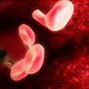 | To carry oxygen | - Large surface area  - Contains haemoglobin
White Blood Cell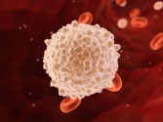 | To destroy pathogens (germs) | - Can engulf cells  Can produce antibodies
Nerve cells  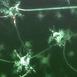 | To carry nerve impulses (electrical signals) to different parts of the body | - Long to carry signals all over the body  - Synapses at each end for control  - Fatty sheaf to help carry signals faster
Female reproductive cell (egg cell)  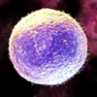 | To join with male cell, and then to provide food for the new cell that's been formed | - Large so contains lots of cytoplasm (nutrients for the growing embryo)  23 Chromosomes in the nucleus (half of a normal cell)
Male reproductive cell (sperm cell)  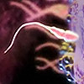 | To reach female cell, and join with it | - Long tail for swimming  - Head contains 23 chromosomes in the nucleus (half of a normal cell)

Type of plant cell | Function | Special features
Root hair cell  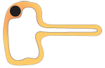 | To absorb water and minerals | - Large surface area
Leaf cell  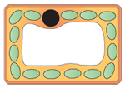 | To absorb sunlight for photosynthesis | - Large surface area  - Lots of chloroplasts
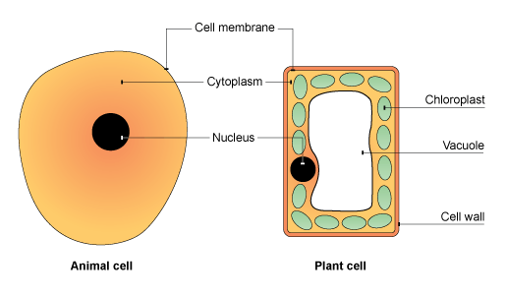
Part | Function | Found in
Cell membrane | Controls what substances can get into and out of the cell. | Plant and animal cells
Cytoplasm | Where chemical reactions happen. | Plant and animal cells
Nucleus | Controls what happens inside the cell. Contains genetic information. | Plant and animal cells
Mitochondria | Where respiration (to generate energy) happens | Plant and animal cells
Chloroplast | Where photosynthesis happens – chloroplasts contain a green substance called chlorophyll. | Plant cells only
Vacuole | Contains a liquid called cell sap, provides support. | Plant cells only
Cell wall | Made of a tough substance called cellulose, which supports the cell. | Plant cells only

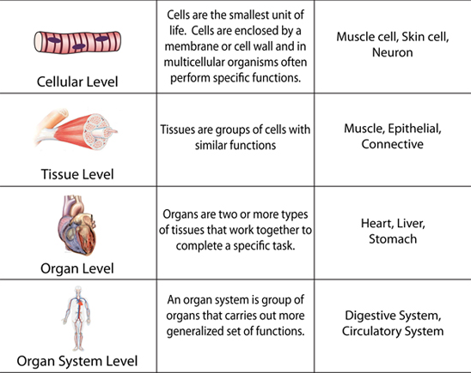

Parts of a Plant and Transpiration
A) Roots: Roots anchor the plant in the soil and take in water and minerals
B) Stem: Xylem cells in the stem carry water and minerals up the plant to the leaves. Phloem cells in the stem carry glucose.
C) Leaf: Transpiration = water evaporates from holes in the leaf (stomata), this pulls water up through the plant.
Photosynthesis also happens in the leaves.

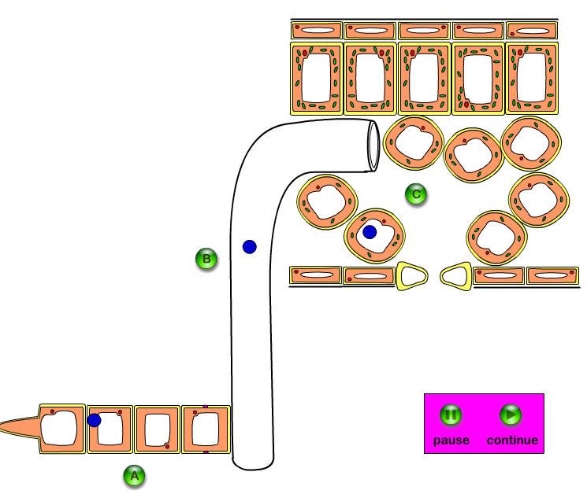
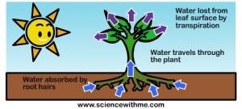

DNA and Inheritance
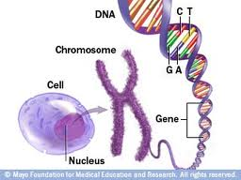
- DNA is made of two strands of bases in a double helix
- Adenine pairs with Thymine A-T
- Cytosine pairs with Guanine C-G
- Sections of DNA are called genes and these are the instructions for characteristics eg: eye colour
- Lots of DNA is packed into a chromosome
- Chromosomes are found in the cell nucleus
- 46 Chromosomes in a normal human cell

Different forms of the same gene are called alleles eg: the gene for eye colour has an allele for blue eye colour and an allele for brown eye colour. One allele comes from your mum and one from your dad.
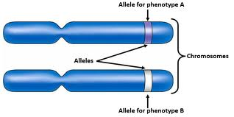
Alleles are dominant or recessive, meaning:
- The dominant allele always produces the characteristic even if you have a recessive allele as well
- The recessive allele characteristic is only shown if you have two recessive alleles
- The disease sickle cell anaemia is caused by a faulty recessive allele
- You only get the disease if you inherit two copies of the recessive allele
- If you have one healthy dominant copy of the allele and one faulty recessive allele then you are a carrier of the disease.

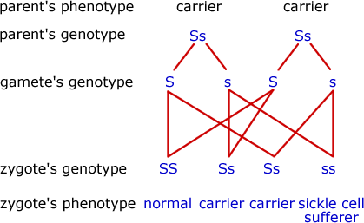
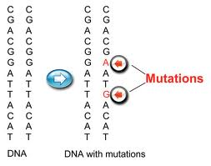
- A mutation is a change in the DNA base sequence
- This can change the characteristics of an organism
- A mutation can cause cancer

Learning Aim B: Nerves and Hormones in Homeostasis
Homeostasis is the maintenance of a constant internal environment eg: keeping your temperature the same.
- Central Nervous System (CNS) = Brain and Spinal cord
- Peripheral Nervous System (PNS) = sensory and motor nerves

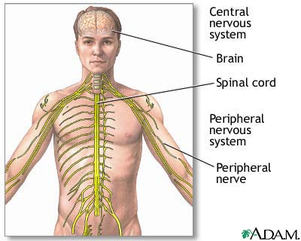
- Nervous system responses can be voluntary or involuntary
- Voluntary = under your control eg: putting your hand up
- Involuntary = a fast reflex action to protect you from harm (see below)

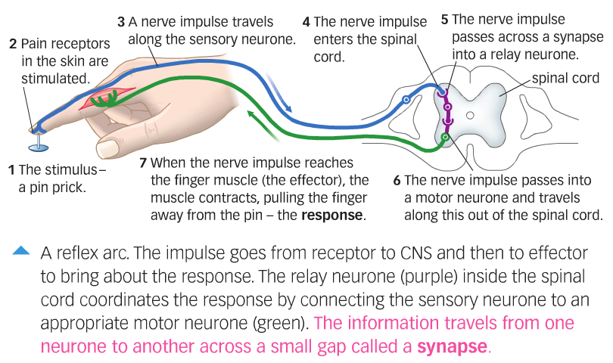
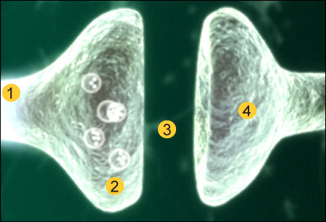
- A synapse is a gap between 2 nerve cells
- An electrical impulse arrives at the first nerve (1+2)
- A chemical (neurotransmitter) crosses the gap (3)
- A new electrical impulse is started in the next nerve cell (4)

Nerves versus Hormones
 | Nerves | Hormones
Speed of Communication | Fast | Slow
Method of Transmission | Electricity | In blood
Duration of Response | Short | Long

Controlling blood glucose (sugar) levels
glucose level | effect on pancreas | effect on liver | effect on glucose level
too high | insulin secreted into the blood | liver converts glucose into glycogen | goes down
too low | insulin not secreted into the blood | liver does not convert glucose into glycogen | goes up
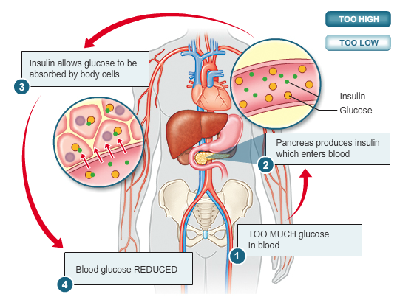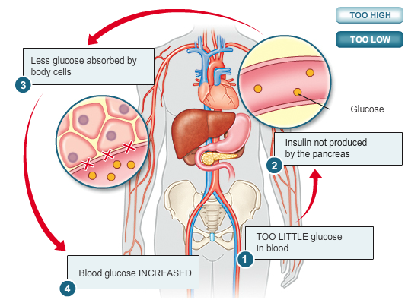
Controlling body Temperature

