BTEC Unit 1 Chemistry Revision
Learning Aim C: Atomic Structure and the Periodic Table
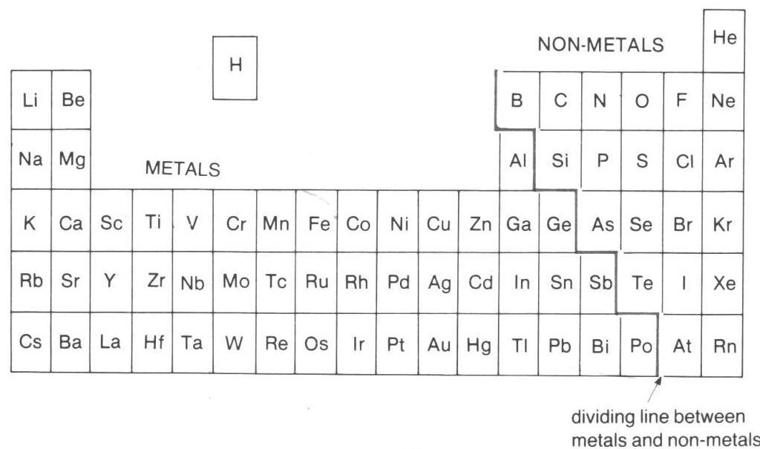
- Metals are on the left hand side of the periodic table, non-metals on the right

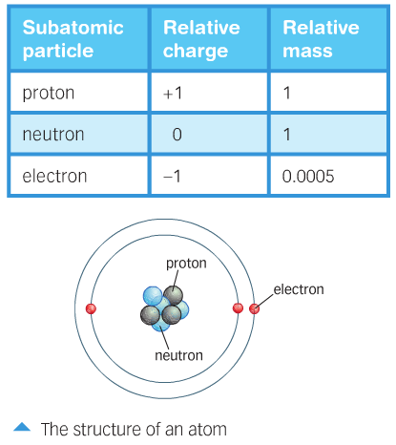
- The nucleus of an atom is very small compared to the size of the whole atom (they are mostly empty space!)
- Atoms of one element ALWAYS have the same number of protons
- Atoms have equal numbers of protons and electrons
- The number of protons in a type of atom are always the same but the number of neutrons can be different = Isotope
- Atomic number = the number of protons
- Mass number = the number of protons and neutrons

Isotope | Protons | Electrons | Neutrons
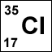 | 17 | 17 | 35 - 17 = 18
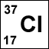 | 17 | 17 | 37 - 17 = 20

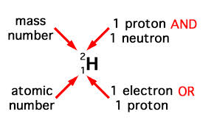

The columns on a periodic table are called groups; elements in a group have similar properties. This is because they have the same number of electrons in their outer shell (Group 1 = 1 electron in outer shell, Group 2 = 2 electrons in the outer shell etc.)
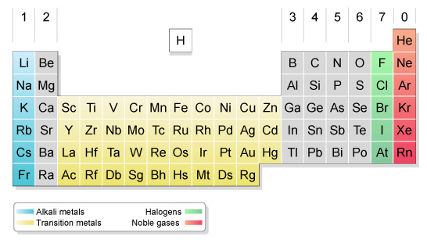

Energy shells
Electrons are arranged in different shells around the nucleus. The innermost shell is filled first. Each succeeding shell can only hold a certain number of electrons before it becomes full. The innermost shell can hold a maximum of two electrons, the second shell a maximum of eight, and so on. The table gives the maximum capacity of the first three shells.
Energy shell | Maximum number of electrons
First | 2
Second | 8
Third | 8
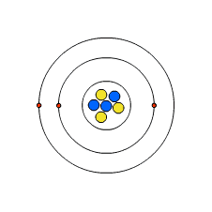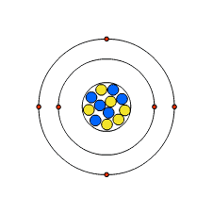
The arrangement of electrons in a lithium atom (2,1)

The arrangement of electrons in a carbon atom (2,4)

Learning Aim D: Substances and Chemical Reactions

Formulas of some compounds, with the number of atoms of each element in the molecule
name | formula | sodium atoms | hydrogen atoms | carbon atoms | sulphur atoms | oxygen atoms
oxygen | O₂ |  |  |  |  | 2
carbon monoxide | CO |  |  | 1 |  | 1
carbon dioxide | CO₂ |  |  | 1 |  | 2
water | H₂O |  | 2 |  |  | 1
sulphur dioxide | SO₂ |  |  |  | 1 | 2
sulphuric acid | H₂SO₄ |  | 2 |  | 1 | 4
sodium carbonate | NaCO₃ | 1 |  | 1 |  | 3

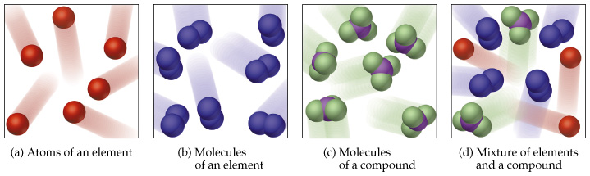
Element = Made of one type of atom only
Compound = Made of two or more different types of atoms bonded together
Molecule = 2 or more atoms bonded together (can be an element or a compound)
Mixture = Made of several substances not bonded together


- All acids:
- have a low pH (1-6) – the lower the number the stronger the acid
- react with bases to form neutral compounds
- are corrosive when they are strong
- are an irritant when they are weak.

Irritant

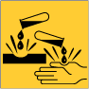
Corrosive

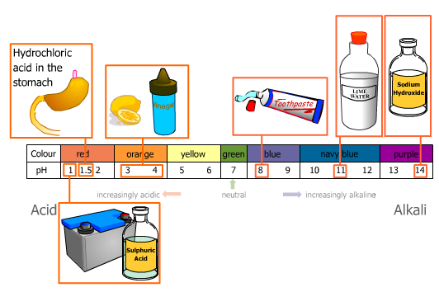
The colours given above are for testing pH with universal indicator
Strong Acid = Red Weak Acid =Yellow
Strong Alkali = Purple Weak Alkali = Blue
Neutral = Green

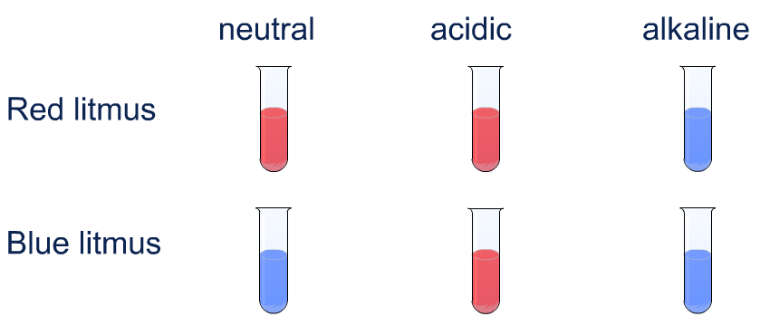

Bases and alkalis
Bases are substances that react with acids and neutralise them. They are usually metal oxides, metal hydroxides, metal carbonates or metal hydrogen carbonates. If a base dissolves in water, we call it an alkali. Alkalis have a pH of between 8 (weak alkali) to 14 (strong alkali)
- Copper oxide is a base because it will react with acids and neutralise them, but it is not an alkali because it does not dissolve in water.
- Sodium hydroxide is a base because it will react with acids and neutralise them. It's also an alkali because it dissolves in water.
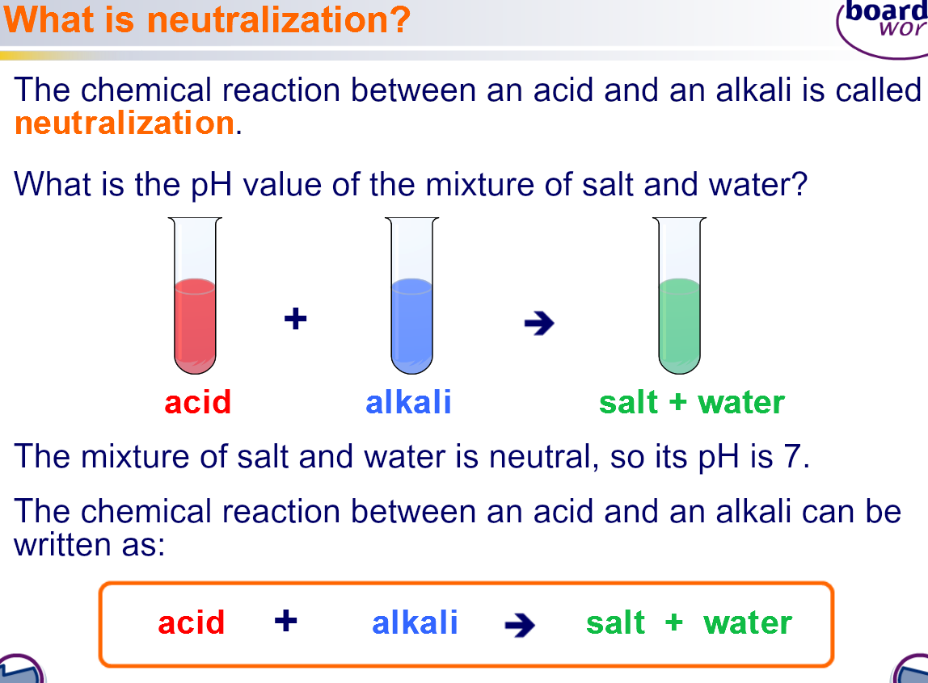

Naming salts
A salt is always made when an acid is neutralised by a base. But the exact salt made depends upon which acid and base were used.
The name of a salt has two parts:
- the first part comes from the metal in the base used
- the second part comes from the acid that was used
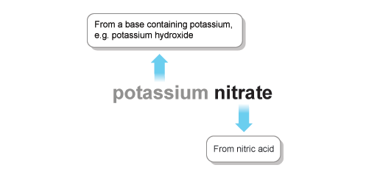
Acid used | Second part of salt's name
hydrochloric acid | chloride
sulphuric acid | sulphate
nitric acid | nitrate

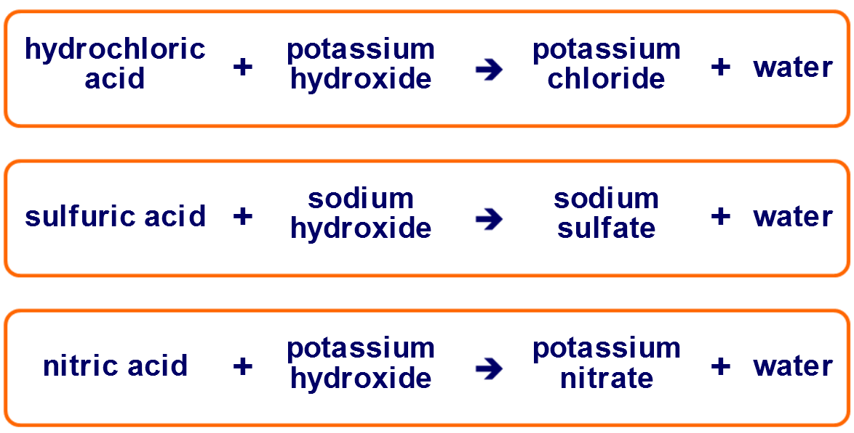

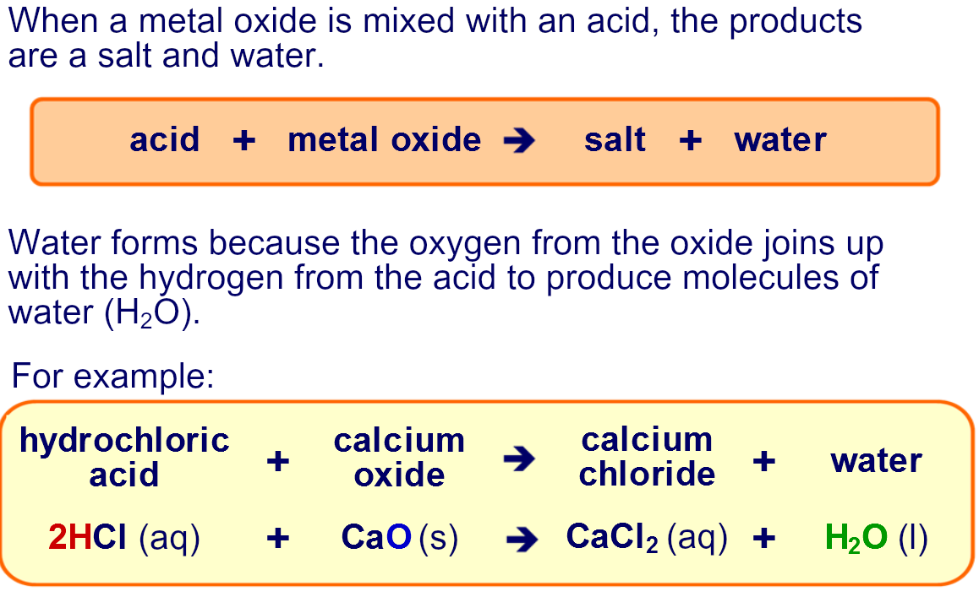

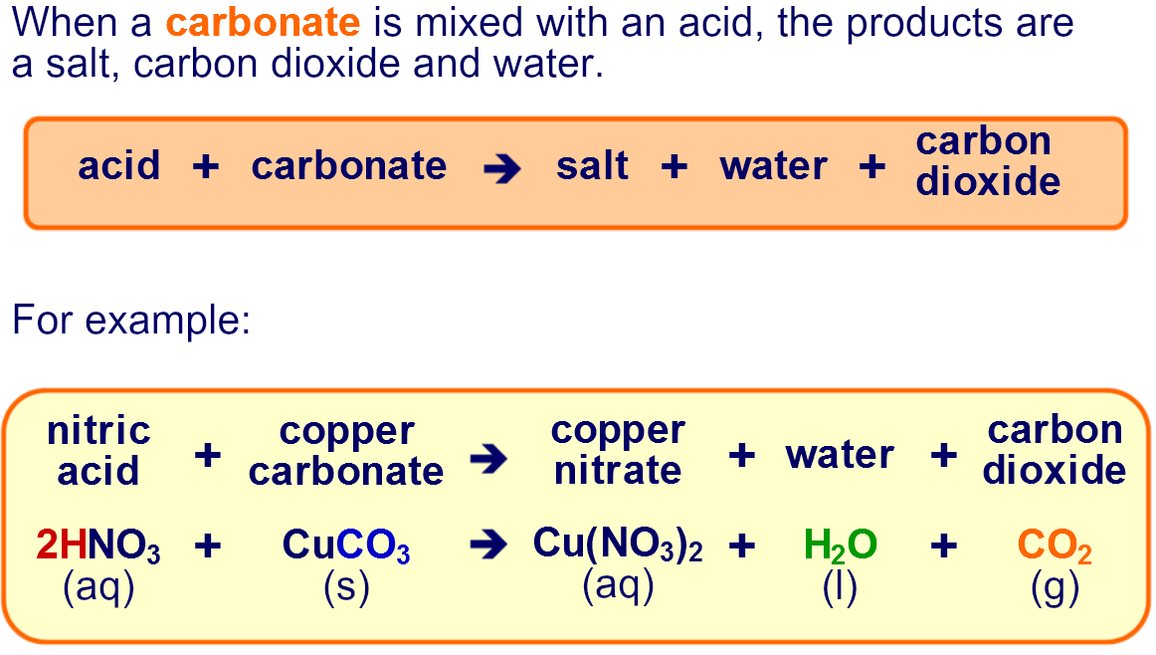

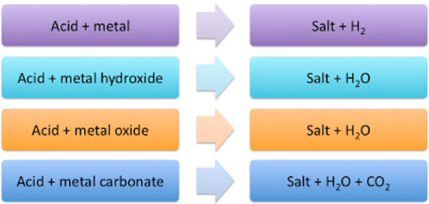

Neutralisation reactions can be used to
- Cure indigestion by taking an indigestion tablet containing a base
- Neutralise acidic soils/lakes using limestone (calcium carbonate) which is a base


